HAWASSI-AB 2D

User Manual



by

© LabMath-Indonesia

ver. 10 February 2024

mail address : LabMath-Indonesia

Lawangwangi - LMI

Jl. Dago Giri No.99

Lembang,

Bandung 40391, Indonesia

e-mail : [hawassi@labmath-indonesia.org](mailto:hawassi@labmath-indonesia.org)

: [info@labmath-indonesia.org](mailto:info@labmath-indonesia.org)

home page : [www.hawassi.labmath-indonesia.org](http://www.hawassi.labmath-indonesia.org)



Copyright ©2015 LabMath-Indonesia

Contents

Preamble 1-4

1 Introduction 1-6

2 Description of HAWASSI-AB 2-7

2.1 Introduction HAWASSI-AB 2-7

2.2 Units and computational grid 2-9

2.3 Model features and capabilities 2-9

*2.3.1* Model versions (evolution equations) 2-9

2.3.2 Spatial setup (geometry) 2-10

2.3.3 Wave Input 2-12

2.4 Software facilities 2-14

3 Installing HAWASSI-AB software 3-15

3.1 System requirements 3-15

3.2 First step: Installing MCR 3-15

3.3 Second step: Installing HAWASSI-AB 3-15

4 GUI’s of HAWASSI-AB 4-16

4.1 Start page GUI 4-16

4.2 New project GUI 4-16

4.3 Main GUI 4-17

4.3.1 Input tab 4-19

4.3.2 Preview 4-25

4.3.3 Post-processing 4-29

4.3.4 Internal Flow 4-33

4.4 lay-out of user defined input files 4-34

4.4.1 Boundaries 4-34

4.4.2 Bottom 4-34

4.4.3 Initial wave profile 4-35

4.4.4 Influx 4-35

4.4.5 Boundary assimilation 4-36

4.4.6 External measurement data 4-36

5 Test cases 5-37

5.1 Non-breaking waves above flat bottom 5-38

5.1.1 2dF001Harm: Harmonic wave 5-38

5.1.2 2dF002HarmDifrac: Diffracted harmonic wave 5-38

5.1.3 2dF003Simple_Harbour: Harmonic wave in a rectangular basin 5-39

5.1.4 2dF004SimpleHarbour 5-39

5.1.5 2dF005SimpleHarbour 5-40

5.1.6 2dF006Simple Harbour: Omni direction waves 5-40

5.1.7 2dF007Biharm: Biharmonic wave 5-41

5.1.8 2dF008DraupnerSea 5-42

5.2 Breaking waves above flat bottom 5-43

5.2.1 2dFBr001Foc: Focussing wave 5-43

5.2.2 2dFBr002_Irreg: Irregular wave 5-43

5.3 Non-breaking waves above non-flat bathymetry 5-44

5.3.1 2dB001HarmRefr: Refracted harmonic wave 5-44

5.3.2 2dB002HarmShoaling 5-44

5.3.3 2dB003AccessChannel 5-45

5.4 Breaking waves above bathymetry 5-46

5.4.1 2dBBr001_HarmBr_BB93 5-46

5.4.2 2dBBr002Ir 5-46

5.5 Wave runup on shore 5-47

5.5.1 2dR001Harm 5-47

5.6 Breaking wave runup on shore 5-48

5.6.1 2dRBr001_MoLiu_IR2 5-48

6 References 6-49

6.1 References to basic papers and applications 6-49

6.2 Other references 6-50

# Preamble

Waves are fascinating, important and challenging.

The importance can be substantiated from some well-known observations:

* Half of the world population lives less than 150 km from the coast
* The sea is a relatively easy medium for transport of people and goods (half of all the world crude oil and increasingly more natural gas) and for intercontinental telecommunication through cables
* Ocean resources of food and minerals are only at the start of discovery, profits from wind parks and harvesting of wave energy in coastal areas is expanding.

Therefore, a sustainable and safe development of the oceanic and coastal areas is of paramount importance. Nowadays that means that for the design of harbours, breakwaters and ships, calculations are performed with increasingly more accurate and fast simulation tools. Tools that are, packaged in software, based on the basic physical laws that describe the properties of waves, the wave-ship interaction, the forces on structures, etc.

HAWASSI software aim to contribute to extend the accuracy, capability and speed of existing numerical methods and software using applied-mathematical modelling methods that are at the basis.

A basis with a rich history that is fascinating and challenging. Starting in the 18th century with Euler who generalized Newton’s law for fluids, in the 19th century Airy ‘solved’ the problem to describe small amplitude surface water waves. In that same century, many renowned scientists like Scott Russel, Stokes, Boussinesq, Rayleigh and Korteweg & De Vries investigated the nonlinear aspects of finite amplitude waves. As much as possible without the need to fully calculate the internal fluid motion; started with Boussinesq in an approximative way, this was formulated accurately in the 1960-1970’s by Zakharov and Broer by providing the Hamiltonian form of the dynamic equations.

HAWASSI software is based on these last findings, with methods for making the principal description into a practical (numerical) modelling and implementation tool.

The first releases of the software deal with wave propagation, but the developers are in the process to extend the capabilities to include coupled wave-ship interactions, amongst others, in later releases.

We sincerely hope that the use of the software, just as the design of it has been, will be fascinating and challenging for students and academicians as well as for practitioners; from both groups we hope to receive comments and suggestions for further improvements and extensions in a way that can be profitable for both sides.

*Let nature tell its secrets*

*Listen to the physics in its mathematical language*

*Restrain from idealization*

*Only then models will serve us in abundance*

© Copyright of HAWASSI software is with LabMath-Indonesia, an independent research institute under the Foundation Yayasan AB in Bandung, Indonesia.

The software has been developed over the past years to become applicable for simulations in two horizontal dimensions, 2HD. This is an essential extension of the 1HD software, that was developed in collaboration with the University of Twente, Netherlands, with additional financial support of Netherlands Technology Foundation STW / NWO and Royal Netherlands Academy of Arts and Sciences KNAW.

This program is free software: you can redistribute it and/or modify it under the terms of the GNU General Public License as published by the Free Software Foundation, either version 3 of the License, or (at your option) any later version.

This program is distributed in the hope that it will be useful, but WITHOUT ANY WARRANTY; without even the implied warranty of MERCHANTABILITY or FITNESS FOR A PARTICULAR PURPOSE. See the GNU General Public License for more details.

You should have received a copy of the GNU General Public License along with this program. If not, see <http://www.gnu.org/licenses/>.

By downloading and using the software you agree that Yayasan AB is not liable for any loss or damage arising out of the use of the Software. Although much care is taken to arrive at trustful results of simulations with HAWASSI, Yayasan AB cannot be held responsible for any result of simulations obtained with the software, or consequential actions or calculations that are based on the results, e.g. because of possible bugs, wrong use of the software, or other causes.

# Introduction

This document is the Manual of HAWASSI-AB 2D software that serves as a guide for using and running the software.

HAWASSI-AB 2D simulates phase resolved waves for coastal and ocean environments: 2 Horizontal Directions (2 HD, long or short crested waves). The software can also be used for designing wave experiments in wave tanks to simulate on scale coastal and oceanic waves above flat and varying bathymetry, and with the possibility to add (partially) reflecting walls and damping zones.

For long crested waves we refer to the manual for HAWASSI-AB 1D.

Section 2 describes briefly the mathematical background and the capabilities of the code, such as the various dispersive and nonlinear properties, together with the features of the software; it is advised to read this Section before continuing to the rest of the manual.

Section 3 provides a step-by-step installation procedure of the software.

A condensed description to handle the software, regarding GUIs and input/output parameters, is given in Section 4.

Section 5 describes briefly 17 Test-Cases that will show capabilities of the code and its use, and can be used as a first set-up for a desired simulation.

# Description of HAWASSI-AB

## Introduction HAWASSI-AB

This section provides background information of HAWASSI-AB about the basic scientific ideas.

HAWASSI – AB is a software package for the simulation of realistic waves in wave tanks (1HD), i.e. long-crested waves, and short crested waves (2HD) with a directional spectrum to simulate waves in oceanic and coastal areas, and in complicated areas with break waters and in harbours with (partial) reflections from walls with prescribed reflection properties.

The acronym HAWASSI stands for

**Hamiltonian Wave-Ship-Structure Interaction**.

HAWASSI –AB is a spatial-spectral implementation of the **Analytic Boussinesq** Model (AB).

Presently the code is for simulation of wave-structure interactions.

Coupled wave-ship interaction is under development, and available soon for 1HD applications.

Besides that, a Radar-module is being finalised to be used to extract detailed wave information over more than 10 km2 from images obtained by a standard X-band radar. The changes of the waves in shallower water is also used to determine the bathymetry from the images.

**Underlying Modelling Methods**

HAWASSI-AB is based on the following principles

* The free surface dynamics for inviscid, incompressible fluid in irrotational motion is governed by a set of Hamilton equations for the surface elevation $η$ and the surface velocity $u=(u,v)$ at the surface.
* With $H\left(u,η\right)$ the Hamiltonian, the sum of potential and kinetic energy, the Hamilton equations are given by (Zakharov 1968, Broer 1974)

$\left\{\begin{matrix}∂_{t}η=-∇⋅{ δ}_{u}H\left(u,η\right) \\ ∂_{t}u=-∇δ_{η}H\left(u,η\right) \end{matrix}\right.$

Here $∂_{t}$ denotes the time derivative and $δ_{u}$ the variational derivative with respect to $u$ and similarly for $η$.

* By approximating the kinetic energy functional $K\left(u,η\right)$ as an expression explicit in $η$ and $u$ the simulation of the interior flow can be avoided: the Boussinesq character of the code.
* The way of approximating $K\left(u,η\right)$ is based on Dirichlet’s principle for the boundary-value problem in the fluid domain. By restricting the set of competing functions in the minimization, an approximation of $K\left(u,η\right)$ is obtained. The variational derivative

$-∇⋅{ δ}_{u}H\left(u,η\right)=∂_{N}Φ$

is the corresponding consistent approximation of the Dirichlet-to-Neumann operator at the surface.

* The (approximate) Hamilton system conserves the (approximate) positive definite total energy exactly, avoiding sources of instability.
* The time dynamics is explicit, no CFL-conditions are required. Time stepping is done with matlab odesolver code, with automatic variable time step.

In AB (with exact dispersion) the interior flow is approximated by using a nonlinear extension of the potential as given by the Airy theory of small amplitude waves, and Taylor expansion of the kinetic energy leading to Hamiltonian consistent approximations.

Output of a simulation can be used in a post-processing step to obtain the full kinematics, so including the internal fluid flow.

**Numerical Implementation**

Fourier Integral Operators (FIO’s) multiply the Fourier Transform of a function by the symbol of the operator. These are generalizations of (Pseudo-) Differential Operators since for FIO the symbol will depend on both the wave number and the spatial variable; the spatial dependence is for nonlinear extensions and varying bottom. FIO’s are used in a spatial-spectral implementation; these are approximated by interpolation techniques to enable efficient Fast Fourier Transformation (FFT) -methods [16]. Localization methods (a difficult point in Fourier-type implementations) are successfully implemented to deal with walls, run-up, breaking waves, etc. [3,9]

## Units and computational grid

HAWASSI-AB expects all quantities to be expressed in S.I units: *m, kg, s* (meter, kilogram, second). As a consequence, the wave height and water depth are in *m*, wave period in *s*, etc.

## Model features and capabilities

HAWASSI-AB can simulate waves in 2 HD, i.e. ***long and short –crested non-breaking and breaking waves*** above flat and varying bottom and in complicated spatial areas with various boundaries such as harbours.

### Model versions (evolution equations)

***All combinations are possible of choices for nonlinearity, dispersion, current and breaking***, with various choices for each item as described below.

#### Nonlinearity

The ***order of nonlinearity*** of the Hamiltonian System (HS) is specified by the number in the present version of HAWSSI-AB

**HS*m* for orders *m=1* (linear), *2 and 3***

#### Dispersion

The main property of HAWASSI-AB is that it can handle ***exact dispersion*** of small-amplitude (so-called *linear*) waves of any wave length, owe to the Fourier character and implementation of AB.

As a consequence, the continuity equation is exactly satisfied above flat bottom, and in a very good approximation above varying bottom.

Besides that, mainly for *educational/academic purposes*, to enable simulations for models with approximate dispersion, other predefined dispersive models can be chosen:

* ***Shallow Water (SW) dispersion***
* ***KdV (Korteweg-de Vries) dispersion*** [KdV 1895]
* ***BBM (Benjamin-Bona-Mahony) dispersion*** [BBM 1972]

A brief explanation is given, referring to the table for the explicit expressions. The exact dispersion relation $ω=Ω_{ex}\left(k\right)$ is the correct expression for small amplitude waves. For $kd→0$, i.e. ‘rather’ long waves or ‘rather’ shallow water, this relation can be Taylor expanded, leading to

* ***SW dispersion*** (first order Taylor) $ω=Ω_{SW}\left(k\right)$, which gives a translation of waves of any wave length with the limiting speed $c_{0}=\sqrt{gd}$
* ***KdV – dispersion*** (3th order Taylor) $ω=Ω_{KdV}\left(k\right)$; note that short waves with $kd>\sqrt{1/6}$ will travel in the opposite direction.

*Remarks:*  Since influxing uses properties of the group-velocity, *Uni-directional influxing* in the KdV model will show the short waves running in the ‘wrong’ direction, corresponding to the dispersion relation. *Bi-directional influxing* will include these wrongly-directed waves, which is *not* corresponding to the original KdV dispersion relation for uni-directional waves.

* ***BBM-dispersion $ω=Ω_{BBM}\left(k\right)$*** , same as KdV in 3th order, but uni-directional

Note: To avoid problems with too poor dispersion, KdV and BBM uses exact dispersion for influxing.

In the table the explicit formulas and plots for the various cases are given.

|  |  |  |
| --- | --- | --- |
| **Model** | **Dispersion relation** | **Plots Disp. relation & Phase velocity** |
| Exact dispersion | $ω=Ω_{ex}\left(k\right)=sign\left(k\right)\sqrt{gk\tanh\left(kd\right)}$ |  |
| Shallow Water | $$ω=Ω_{SW}\left(k\right)=c_{0}k\text{ with }c_{0}=\sqrt{gd}$$ |
| KdV | $$ω=Ω_{KdV}\left(k\right)=c_{0}k\left(1-\frac{1}{6}{\left(kd\right)}^{2}\right)$$ |
| BBM | $$ω=Ω_{BBM}\left(k\right)=\frac{c_{0}k}{\left(1+\frac{1}{6}{\left(kd\right)}^{2}\right)}$$ |

#### Current

For waves in currents, the dispersion relation is modified by adding $k⋅u$ with $k$ the wave vector and $u=(u_{x},u_{y})$ the current speed vector ($u_{x},u_{y}$) that has to be specified.

#### Breaking [10]

Breaking of waves is modelled with an eddy viscosity method; to initiate the breaking process, the value of a kinematic initiation ***breaking criterion*** has to be specified, the quotient of fluid velocity at the crest and the velocity of the crest: ***U/C***, usually in the interval *[0.6, 1]*

### Spatial setup (geometry)

#### Domain area

***Simulation interval and Grid***  
A uniform grid is defined by specifying an *x*-interval $\left[x_{min}, x_{max}\right]$ and *y*-interval $\left[y_{min}, y_{max}\right]$ and a grid with grid size

$dx=\left(x_{max}-x_{min}\right)/(N_{x}-1)$ and $dy=\left(y_{max}-y_{min}\right)/(N_{y}-1)$

Here the number of points $N$ has to be chosen such that the largest prime factor satisfies $N≤13$.

The choice of *N* determines the computation speed of FFT calculations; the fastest computation speed will be achieved when the largest factor of *N* is 2.

*Wave numbers* in Fourier space are defined as $k=\sqrt{k_{x}^{2}+k_{y}^{2}}$ with $k_{x}$ and $k_{y}$ in accordance with the spatial grid:

$k_{x}=\left[-\frac{N_{x}}{2}+1:\frac{N_{x}}{2}\right]dk_{x}$ and $k_{y}=\left[-\frac{N_{y}}{2}+1:\frac{N_{y}}{2}\right]dk_{y}$

with $dk_{x}=2π/(x_{max}-x_{min})$ and $dk_{y}=2π/(y_{max}-y_{min})$.

***Cut fraction of wave number***

To avoid aliasing in the Fourier implementation, the wave numbers have to be restricted to be at most a fraction *1/(2m)*, with *m* the so-called ***cutfrac*** in the input for the specified code. A default value of cutfrac should be given to the software, $m=2, 4, \text{and} 6$ for HS 1, 2 and 3 respectively. (Note: This cut only applies to the terms in the nonlinear equation; the spatial grid remains as determined by *N* gridpoints.)

#### Boundaries

***Walls***

The software provides parameterized wall shape for rectangle and circle. The position of a wall inside the simulation interval can be specified. The shape of the wall can be user-specified. There are two methods of wall implementation. One method is based on an energy truncation method as described in [3,9] and another one based on an influxing method [11].

Depending on the desired reflection properties, a ***uniform, fully or partially reflecting wall*** can be added by specifying the reflection coefficient in (0,1) for all wave lengths (frequencies).

For the influxing wall method, a non-uniform (frequency dependent) partial reflection can be applied by providing a formula with a variable frequency (*w [rad/s]*) in the input equation column in MATLAB formula style.

***Fourier Boundary***

For the use of Fast Fourier Transformations, all quantities (except the bathymetry) are tapered to vanish near the end points; this takes place is the so-called ***Fourier Boundary***, the length of which can be specified. The Fourier Boundary should be such that reflection of outgoing waves is prevented; hence the Fourier Boundary also acts as a ***damping zone***. The location of the damping zone can be user-defined by specifying boundary data and a smoothing factor (as a factor of the grid size).

#### Bottom

The ***bathymetry*** can be user-specified. The software provides parameterized bathymetries, for flat bottom (depth), and linear sloping (parts of the) bottom in *x* or *y*-direction. For interpolating the depth depending Fourier Integral operators, the number of depths can be chosen to be 2 or 3; except for very abrupt, large changes, the choice of 2 depths gives usually sufficient accuracy.

*The bathymetry for Run-up on a coast can be user-specified by defining the positive bottom profile as a land. The software provides parameterized bathymetry for linear sloping (parts of the) bottom with shoreline in x or in y direction. A minimal total depth for parameterizing shoreline has to be specified, i.e 2% of the significant wave height. For interpolating the Fourier integral operators, the number of depths reference are 3, and the mid-depth reference has to be specified.*

***Bottom friction***

Bottom friction can be applied at a specified part of the bottom; in the bottom friction formula

$$R_{f}=-\frac{g n_{M}^{2}}{{\left(D+η\right)}^{4/3}}u\left|u\right|$$

typical values for the manning coefficient are $n_{m}∈\left(0.01,0.05\right)$ depending on bottom.

### Wave Input

#### Initial Condition

Data for an initial value problem (***initial elevation profile*** and ***initial potential***) can be user-specified or chosen from predefined parameterized cases: a ‘*Gaussian*’ as a single hump, and ‘*Nwave*’ for an N-wave shaped wave *along the x or y axis*, all with zero initial potential.

The Gaussian is given by specifying the three parameters in

$η\left(x,0\right)=A\exp\left({-{\left(x-x_{c}\right)}^{2}}/{σ^{2}}\right)$ or $η\left(0,y\right)=A\exp\left({-{\left(y-y_{c}\right)}^{2}}/{σ^{2}}\right)$

and the N-wave is the derivative with adjusted amplitude.

#### Wave influxing

In AB the wave influxing is done through a source in the continuity equation.

***Wave types***

Any type of waves can be influxed from a ***user-specified time signal or a user-specified variance density spectrum***.

The software makes it possible to specify parameters for ***harmonic waves*** and for ***irregular waves*** with JONSWAP (JS) spectrum; for irregular waves, the phases are chosen randomly. The parameterized influx signal will be stored for possible re-use for comparison of different evolution models.

For a choice of the user-specified variance density spectrum or the JONSWAP spectrum, a directional spreading width parameter $s$ has to be specified. The directional spreading function is formulated as

$$D\left(θ\right)=\left\{\begin{matrix}A_{1}\cos^{2s}{θ} & \text{for }\left|θ\right|≤90° \\ 0 & \text{for }\left|θ\right| >90°.\end{matrix}\right.$$

The relation of the width parameter $s$ and the half directional width $σ_{θ}$ [rad] is

$$σ_{θ}={\left(\sqrt{2/{\left(s+1\right)}}\right)}/2$$

For the choice of wave type, except the user-defined signal, a main wave direction has to be specified. The direction is in degree with $0°$ to the East, $90°$ to the North, $180°$ to the West and $270°$ to the South.

***Influxing method and position [11]***

The spatial extent over which the influx takes place can be chosen:

With a ***point-influx*** the ‘generation area’ is restricted to the immediate neighbourhood of the influx line (using Dirac delta-functions). Then the desired time signal is modified into a (much) higher modified time signal to guarantee the correct waves being influxed.

A smoother influx method is ***area-*** ***influxing***; then the waves are generated over a broader interval; this area-influxing is to be preferred in general, especially it is better suited for high, steep waves.

In deep water case, the point-influx is better suited than the area influxing.

The ***influx line type: a straight line or a circular arc can be chosen and the*** ***time interval*** of the influx have to be specified.

***Ramp functions*** *[11]*

Any influx signal will start and end by default with a smooth ***ramp function***, the length of which can be specified as a number of periods. A ramp function for the end of influxing line can be specified as a factor of the influx length to prevent (strong) diffraction from the endpoints, used in particular when long crested waves are to be simulated in 2D domains.

***Nonlinear adjustment zone*** *[11]*

In order to prevent spurious modulations in the influxed wave when using a nonlinear wave model, a nonlinear adjustment zone of length to be specified has to be applied; in the adjustment zone a coefficient in front of the nonlinear terms in the Hamiltonian grows from 0 at the influx point to 1 at the end of the zone. Typically, especially for harmonic waves, the required length will be at least 2 times the peak-wavelength (and somewhat more for steeper waves on shallower water).

#### Boundary Assimilation [2]

The usual influx method from a straight line will generate waves in directions around a main propagation direction. For broad multi-directional waves not bounded by lateral walls, a substantial amount of waves (energy) will be annihilated (‘leave the domain’) at the lateral damping zones while propagating downstream, and thereby also influence waves over increasingly further lateral distances.

This problem can be avoided by influxing on circular arc (Sec. 2.3.3.2) or with an alternative *assimilation* influx scenario. The assimilation influx scenario is to solve after each assimilation time step an initial value problem. The data are the ongoing evolution below an assimilation area, and the updated wave data above it; in a small joint overlapping area the data are merged smoothly at the time of the update. See figure 1, where the merging area is the orange-coloured semicircle area that is constructed as the area between the boundary of the semicircle and a vertical shift upwards of this boundary.

To design the merging area, the radius, the centre of the circle, and a smoothing factor, have to be specified. The elevation data has to be specified but specifying the potential is optional: if not specified, the potential is calculated according to linear theory at the time of the updates. Nonlinear adjustment is optional. The time interval of the assimilation and the time step in between updates have not to be specified.

Fig 1. Illustration of the boundary assimilation method: orange. the area above the semicircle is the assimilation area, and the area below it is the main simulation area.



## Software facilities

Facilities of the software include (described in detail in Section 4)

* ***Panel for input*** of wave characteristics and model parameters, with efficient project management
* ***Panel for preview*** of dispersion, spatial set-up and wave input plots and a log-file.
* ***Panel for post-processing*** of the output of the wave simulation and comparison with data
* ***Panel for internal-flow post-processing*** of output to get full kinematics in 3HD
* ***Wave Calculator***
* ***Time partitioned simulation*** to reduce (computer) hardware requirements
* ***Pre-processing step*** with warnings/suggestions for improved settings
* 14 ***TestCases*** (see Chapter 5) with examples of various kind, several of which include measurement data to compare with simulations.
* ***Comparison with experimental data*** that have been reported in various publications (see the references in Section 6 and the examples of *TestCases* in Section 5).

# Installing HAWASSI-AB software

The HAWASSI-AB installer will install the HAWASSI-AB code, including documentation.

HAWASSI-AB software is programmed under the MATLAB environment. The compiled MATLAB applications can be run on PC’s that do not have MATLAB installed using the MATLAB Compiler Runtime (MCR). The MCR will install MATLAB Runtime Libraries on the computer.

## System requirements

HAWASSI-AB (v.1.1) can run on Windows operating system with 64 bit architecture. The minimum memory (RAM) needed is 2GB (for some test cases and extensive applications 4GB RAM or more).

## First step: Installing MCR

The HAWASSI-AB package (v.1.1) requires MCR installer for version ***MATLAB R2018a*** for Windows operating system 64bit. The MCR installer can be downloaded directly from the MATLAB website: <http://www.mathworks.com/products/compiler/mcr/>; after downloading install the MCR by double clicking the installer and following the instruction in the installation wizard.

## Second step: Running HAWASSI-AB

After installing MCR, HAWASSI-AB can be started by double clicking the executable ‘**HAWASSI_AB_startpage**’.

In the Help- Menu of Main-GUI, the ‘Documentation’ will show this manual. Test Cases can be found in the test case directory.

# GUI’s of HAWASSI-AB

For ease of operation, HAWASSI-AB software includes GUI’s, Graphical User Interfaces, as input-output managers. The GUI’s are a start page GUI, a new project GUI and a Main GUI.

## Start page GUI

This GUI panel is for choosing an existing project from a list previous projects, for browsing for an existing project that is not listed in the panel or for creating a new project by calling a new project GUI.

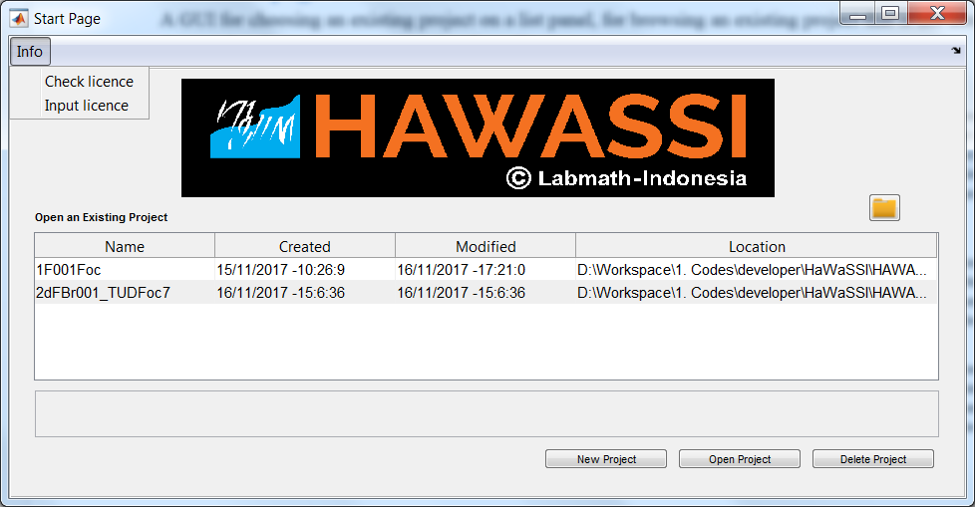

Information about the licence

List of existing projects

Button for opening the chosen project on the list

Button for deleting the chosen project on the list

Panel for notes of the chosen project

Browse button for an existing project that is not listed in the project list

Button for creating a new project

## New project GUI

This GUI panel is for creating a new project by specifying product type, modules, project name, the directory and project’s note. The choice of product type can be AB 1D or 2D for simulations in one or two horizontal dimensions. Module choices are for wave simulations, for wave-ship interactions and for wave-radar applications. The available modules depend on the licence.

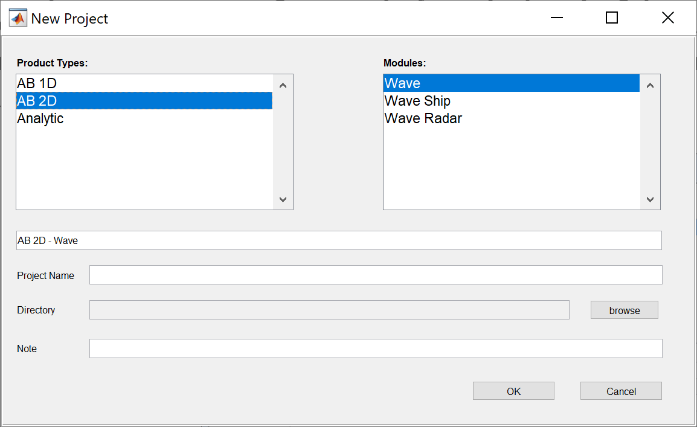

## Main GUI

UI menu

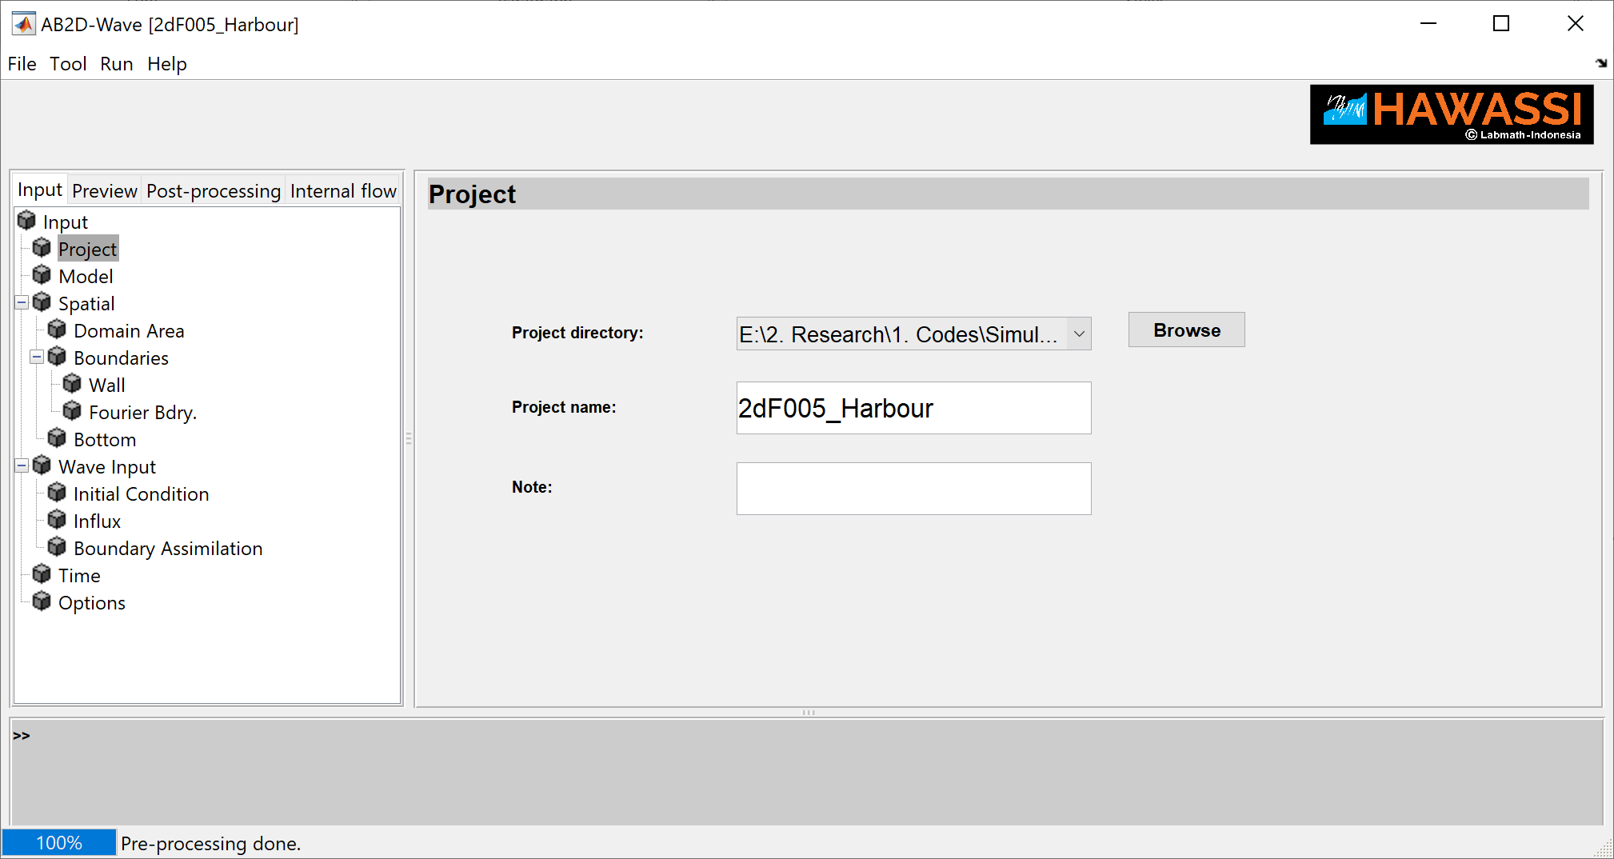

Progress bar

Panel for input or display of the chosen object on the content panel

Panel for warnings /suggestions of the user input or an indication of software process.

Panel of content of the chosen tab

Tabs

The main GUI consists of several panels as shown and described in the above Figure.

**UI menu panel:** consists of *File*, *Tool*, *Run* and *Help*.

Opening ***File*** will show

* ***New Project***: to go to the start page GUI to choose ‘project’ that has been created before (including the provided test cases) from which data can be loaded to be inserted in the GUI or to create a new project.
* ***Save Project***: Save all data entered in the GUI (after pre-processing this info will be stored automatically)

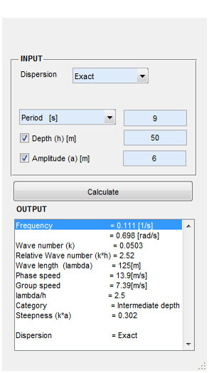

**Wave Calculator GUI**

* ***Clear***: clears the GUI from inserted input
* Quit HAWASSI

Opening ***Tool*** will give the possibility to activate a ***Wave Calculator***. The simple calculator expects as input the period of a harmonic wave and the depth and will then calculate all wave-relevant quantities; by also specifying the amplitude, the calculated steepness is also added.

***Run*** is for executing **Pre-processing** after the input parameters are specified and for executing the ODE calculation (**Start simulation**) after the pre-processing has been executed and preview panel has been checked. A time-indicator estimates the remaining time for the execution process as -shown with a **progress bar** on the bottom of the GUI.

***Help*** contains info about the loaded version in ***About*** and opens this manual in ***Documentation***.

**Tabs** gives access to three successive -processes: **Input**, **Preview** and **Post processing**. The corresponding panels are described ***briefly in the next subsections. The meaning of most required input fields needs no or little explanation; the choices that can be made will be described***. The function of and required input format for input panels is indicated when the cursor is moved over it; when an optional panel is checked, additional input fields may appear that have to be filled out.

User-input is accepted for various purposes to replace pre-programmed choices;

this is the case for

* influx signal
* initial wave profile
* boundaries
* bathymetry
* bottom friction
* measurement data for comparison with simulations

The required lay-out of such files is described in Section 4.4.

### Input tab

Various input panels lead the user to provide information about the simulation set-up; the panels are named **Project, Model, Spatial, Wave Input, Time** and **Options**.

By clicking at the name, the corresponding panel appears and can be filled for specifying the parameters or a choice will show up for further diversification.

The contents of the separate input panels are described below.

#### Project panel.

In the Project panel, a ***project directory****,* ***project name*** and a ***user note*** have to be specified. This project panel is automatically filled if it has been specified as a new project GUI or if an existing project has been loaded. The user can change the given input in the panel.

The ***Project Directory*** is a working directory that is created (when it doesn’t exist yet) by the software.

In this directory a sub-directory is created with the specified as the ‘***Project name***’; if the folder already exists, it will keep and use it. ***ALL*** output of a simulation will be stored in this folder, together with selected output of post-processing.

The ***Note*** gives the possibility to provide details or a short description of the specific simulation; this text is copied to the log-file that will be created after the pre-processing step further on.

#### Model panel

The **Model** panel requires as input:

* choice of the ***dynamic*** model,
* choice of the ***dispersion*** relation,
* for simulations in the presence of a constant ***Current*** the strength has to be specified (and will be added to modify the chosen wave dispersion relation)
* choice of facilitating ***Breaking*** or not.

#### Spatial panel

The **spatial** panel requires input parameters for choices that can be made for the ***Domain Area***, for ***Boundaries*** that consist of wall and Fourier boundary, and for ***Bottom*** bathymetry and bottom friction.

* ***Domain Area.*** Specify the boundary points of a rectangular domain by giving the intervals in the *x* (horizontal) and *y* (vertical) direction.

Then specify the grid size in the two directions; note for fast computation the grid size has to be specified such that the largest prime factor of number of discretization point satisfies $N≤13$.

Then specify the value of **cutfrac** (an even number, see Sec. 2.3.2.1).

***Boundaries - WALL***

In the subpanel **Wall**  is the option to specify details of one wall or several walls (click add row).

Data has to provided for a **rectangular** or **circular** wall; for a **user-defined** wall a prepared file with data format as in section 4.4.1 has to be uploaded.

The data to be specified for a rectangular or circular wall are as follows:

* Rectangular: minimum and maximum position in x and y axes.
* Circular wall: center position in x axis (xc) and in y axis (yc).

Type of wall method: Influxing or Energy truncation has to be chosen.

Reflection properties of the walls has to be specified either uniform reflection coefficient in [0,1] for all wave frequency or nonuniform reflection coefficient (frequency dependent). Nonuniform or frequency dependent reflection coefficient is only available for influxing wall method. In the input equation column, a formula of the reflection coefficient with a variable of radial frequency (***w***) [rad/s] in MATLAB formula style has to be provided.

Note that the influxing wall method suits for wave propagation orthogonal or parallel to a wall,

while the energy truncation method suits for complex layout of wall and omni- direction of wave propagation to the wall. The energy truncation method has difficulty (overshot elevation around wall) for wave propagation parallel to a wall, while the influxing wall method has difficulty for oblique waves propagate to a wall.

* ***Boundaries – Fourier Bdry***

In the subpanel ***F*o*urier Bdry*** is the option to specify details of Fourier boundary or several damping zone (click add row). Required input for the Fourier boundary is the length of boundary for each side of end area simulation domain. Fourier boundary is deactivated by specifying 0 for the length of boundary in each side.

For damping zone, boundary data is required to be user-specified with format data as in Section 4.4.1. Then specify the smoothing factor (odd number) as a factor of the grid size.

* ***Bottom***

In the subpanel ***bottom*** is the option to specify details of bathymetry and bottom friction.

For flat bottom then specify a depth. For slope bottom profile then specify minimum depth, maximum depth, slope and starting position of the slope. For runup cases then specify maximum depth, minimum total depth for defining shoreline (i.e 2% of significant wave height), slope and a position of shore. For user-defined bathymetry, specify a file with format data as in 4.4.2. Positive bathymetry value will be defined as a land and this defines as runup case. In that case, a minimum depth for defining shoreline has to be specified.

Number of depths 2 (default) or 3 has to be chosen for FIO interpolation. In the runup case, the number of depths for the FIO interpolation is 3, then the mid-depth reference has to be specified.

If ***bottom friction*** is applied, specify rectangle or user-defined area of bottom friction. Specify xmin, xmax, ymin, and ymax for the rectangle area of the bottom friction and then specify friction coefficient. For user-defined, specify a file of bottom friction area with data format as in 4.4.2 and then specify friction coefficient.

#### Wave Input panel

The **wave input** panelrequires input parameters for choices between ***Initial condition****,* ***Influx*** and ***Boundary Assimilation***, or combinations thereof.

* ***Initial condition***

Initial elevation profile for predefines cases, Gaussian and N-wave, requires input of amplitude, center position and standard deviation to be specified. For those predefined cases, the initial surface potential is set to be zero.

For user-defined initial conditions, specify a file of initial condition(s) with data format as in 4.4.3. If initial wave potential data is not specified, the wave potential will set to be zero.

* ***Influx***

**In the upper part of the panel** the influx can be given at one or more lines. At each line, (only) the elevation at the line needs to be specified.

In ‘Wave type’ several choices are available:

* ‘Harmonic’ and ‘JONSWAP’ for influx of harmonic waves or waves with JONSWAP spectrum. The waves are constructed by the software after specification of parameters; for JONSWAP random phases are chosen.
* User-defined waves can be specified by providing the link to the file that contains the data of the elevation or data of a prescribed spectrum of the waves. See Section 4.4.4 for the data format.

The (main) ‘Direction’ of the waves has to be specified in degrees (***0 degree is to the East, counted counter-clock wise***).

All input is saved to disk in the project directory after pre-processing; when desired, successive simulations with different set-ups of the dynamic model can be compared with the same influx.

**In the lower part of the panel** information about the influx line is specified.

‘Method’ refers to the way how the specified elevation at the line is treated in the dynamic equations (see Lie et.al. [11]):

* POINT: then the influx is given (only) on each discretization points of the line itself. This requires a modification (done by the software) of the given influx elevation: it is multiplied by the group velocity which will (substantially) increase the amplitudes and may lead to inaccuracies for high-wave influxing.
* AREA: then the given elevations are used but are spread out over an area around the influx line to take care of the correct energy propagation in the desired direction.

There are two options for influxing line:

* Straight line: then specify *xy* positions of the two endpoints of the line.
* Circle arc: then specify center position of the circle, radius, starting degree (*θ1*) of the arc and end degree (*θ2*) of the arc (***0 degree is to the East, counted counter-clock wise***). Note that *θ2* must be in the same quadrant or one quadrant higher than *θ1*.

Then specify starting time, end time and time step of the influx.

At the lowest part of the panel there are three options:

* ‘**Ramp (signal)**’. The given influx signal will be tapered: gradually increased in strength from zero at the start to one at the time specified in the panel as number of peak periods.
* ‘**Ramp (influx line)**’. The influx at the influx line can be tapered: gradually increased in strength from zero at the ends to one at the position of *half* of the fraction that is specified (by *infl.length*) of the length of the influx line.

This is especially useful to prevent large effects of Bragg diffraction when making long crested waves. This tapering will be visible in the plot of the ‘Simulation domain’ in the ‘***Preview*** panel – ***Spatial***’.

* ‘**Nonlinear adjustment**’. To prevent spurious waves when influxing in a nonlinear code (see Lie et al. [11]). The length of the adjustment zone is specified as a multiple of the peak wave length.

This is especially needed when influxing harmonic waves.

If wall boundary with influxing method is applied, then the nonlinear adjustment is also applied in the wall implementation.

* ***Boundary Assimilation***

For boundary assimilation, the shape of the boundary is a half-circle, then the radius of the circle, *xy*-center position and a smoothing factor (as a factor of the grid size) for the merging area has to be specified.

The elevation data has to be specified. If the velocity data is not specified, the velocity is calculated according the linear theory at the time of the updates. The data format is described in Section 4.4.5.

Propagation direction from the inner circle of the boundary has to be chosen to the South, West, North or East, if only the wave elevation data is specified.

Nonlinear adjustment is optional, if it is applied then specify distance to the boundary from the starting position of the adjustment, specify a smoothing factor (as a factor of the grid size) of the adjustment.

The time interval of the assimilation and the time step will be shown on the panel which are based on the specified time interval in the specified elevation data.

#### Time panel

The **time** panel is for specifying the interval of time and the (ode-) time step used during the *simulation*. This panel is automatically filled using the time interval specified in the wave influx file. For multiple wave influxes, the simulation time interval will be the longest of these time intervals, and the time step will be the smallest time step of the wave influxes.

If the time step is changed, all given influx data (also data from files) are interpolated to the time step as now prescribed during the execution of the simulation, the interpolated influx data and the variance density spectrum of the influx data are saved in the project directory after pre-processing.

#### Options panel

In the **Options** panel various default choices and values of parameters can be changed*:*

* The default ***Output variable*** of a simulation is the ***elevation***. The choice can be made to have as output the ***elevation and potential***, which then will increase the size of the data to be twice as large.
* ***Internal flow is*** for calculating **kinematics by specifying time interval and time step for the calculation.**
* ***ODE partition*** will make simulations time-partitioned: storing of part of the output data during the simulation in separate files to reduce the maximum size of each output. By default, the software identifies automatically the number of partitions based on the expected load during the simulation and the maximum number of elements allowed in an array with the used version of MATLAB. The number of partitions can also be user-specified. By default, at the end of the simulation, all partitioned data are combined into one file. If the files are successfully combined, the separate partitioned files will be deleted, if not the partitioned files will be kept. The option to not combined the files is also available.
  + ***ODE rel. error tolerance*** is 0.001 by default but changes can be user-specified.
  + ***ODE solver*** is ODE45 by default. ODE45 is based on an explicit Runge-Kutta (4,5) formula, the Dormand-Prince pair. Another solver with ODE23 is also available as option.
* ***Monte-carlo simulation*** is for multiple simulations with different wave input (amplitude, period, etc.), or by specifying a number of simulation runs, or different grid sizes. Those are described as follows:
* Different wave input: is only available for Harmonic and JONSWAP wave input. For the Harmonic input, various amplitude and/or period can be set. For JONSWAP input, various *Hs*, *Tp*, γ, and/or spreading factor (*s*) can be set for different simulations. If parameter has been specified for each wave input, store data button has to be pushed.

Number of simulation is same as a total of the input parameter plus 1. The plus 1 is from the first setup on the influx panel. For example if the wave input #1 (first influx line) is set for 3 different amplitude; A1;A2;A3, then will be 4 simulation will be executed.

* Number of simulation runs: this is applied for simulations with different (random) phase of JONSWAP.
* Different grid sizes: by specifying various *dx* and *dy.* This option can also be combined with the different wave-input option.

After all input has been set, **RUN** will start the execution of the **pre-processing**. After finishing, preview panels will pop-up and show various plots of the set-up and a log file will have been generated.

### Preview

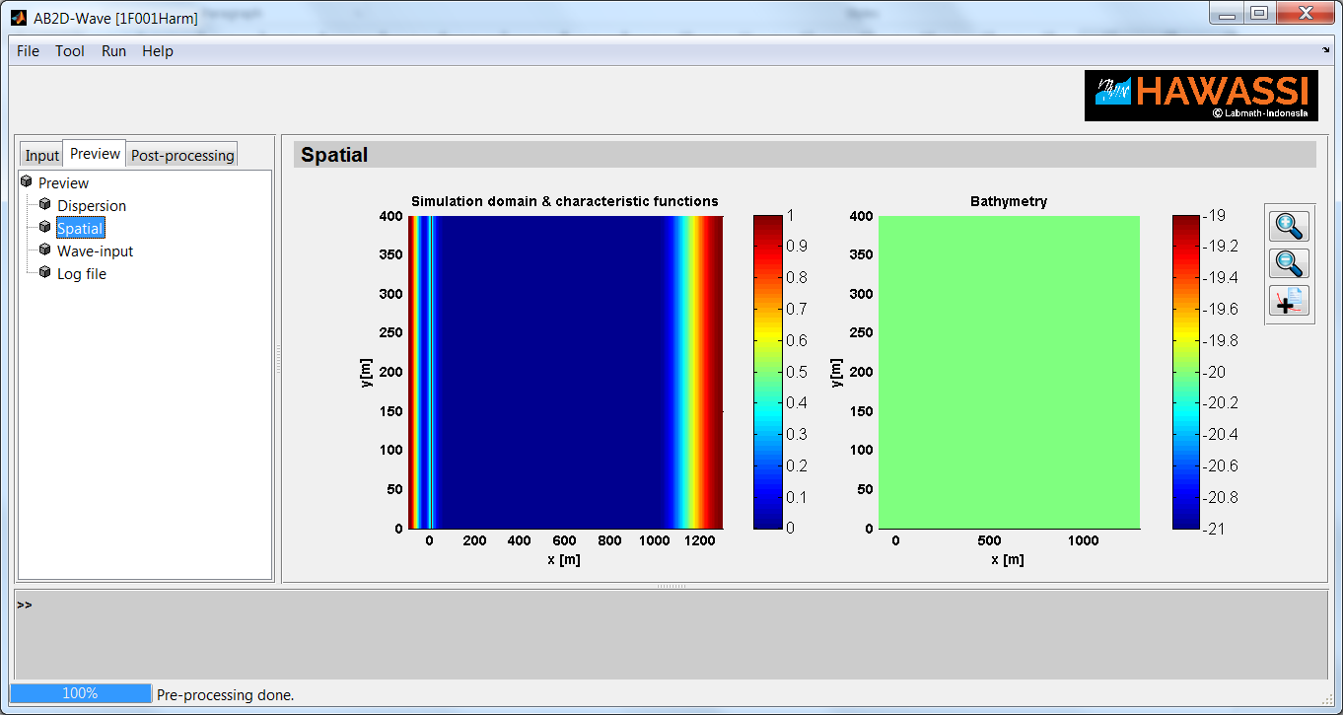After the pre-processing the Preview panel pops-up and shows plots of **dispersion**, **spatial set-up** and **wave input**, and a **log-file** for preview.

In the preview panel, a tool bar is available for zoom in, zoom out and a data cursor.

#### Dispersion panel

The **Dispersion** panel shows at the left the plot of the chosen dispersion relation and at the right the plot of the corresponding phase and group speeds. If an approximate dispersion relation is used, the plots also show the results for the exact dispersion (dashed) for comparison.

In the plots, there are dots that indicate the peak wave numbers and peak frequencies for the first, second, and third harmonic that correspond to the used nonlinear dynamic model. So the first harmonic is located at $\left(k=Ω^{-1}(ν_{p}), ν_{p}\right)$, the second harmonic at $\left(k=Ω^{-1}(2ν_{p}), {2ν}_{p}\right)$ and etc.

In the dispersion plot, the maximum *x*-axis limit indicates a maximum wave number that can be simulated by the model. The maximum value depends on the grid sizes, if the grid size is too large, the indicator of the peak wave numbers will not be shown.

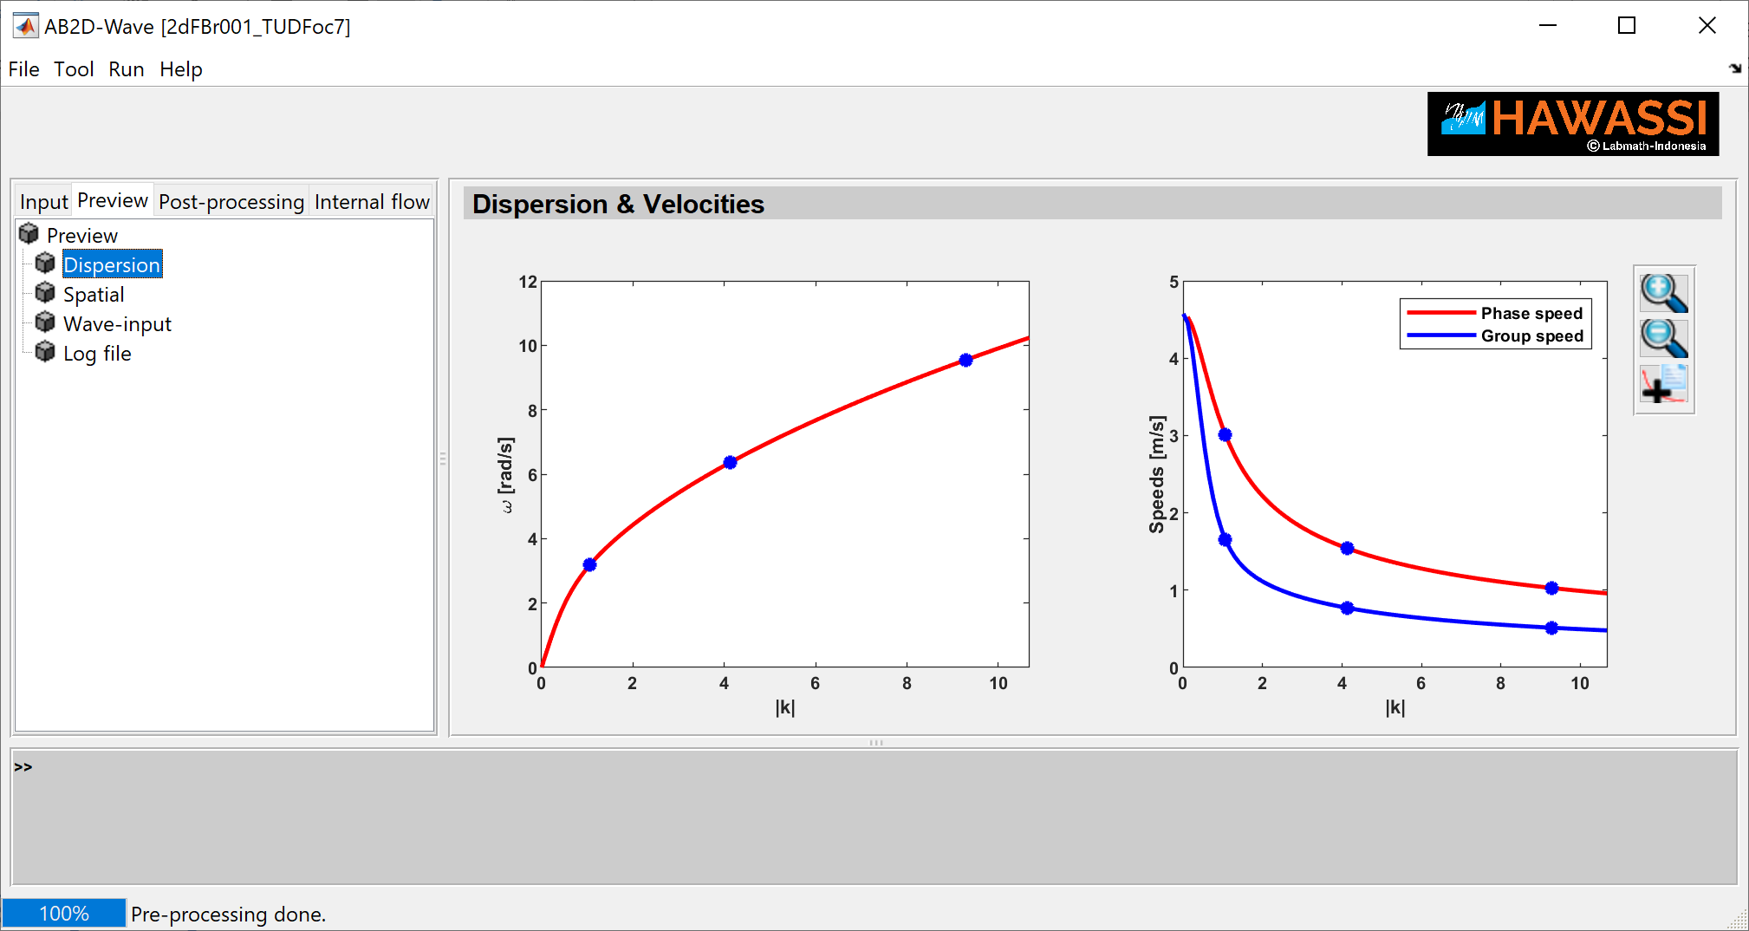

#### Spatial panel

* The **Spatial** panel shows a spatial density plot by choosing one of six options. The options are Fourier boundary and influxing char, influxing char and nonlinear adjustment, bathymetry, bottom friction, wall char and Fourier boundary and influx char, wall influxing char and wall nonlinear adjustment.

Note that the plot will be saved in the project directory only if the plot has been shown in the GUI panel.

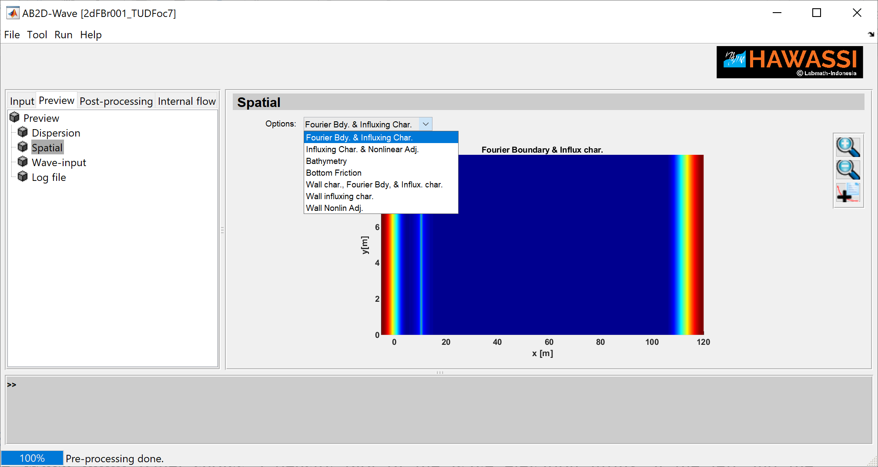

#### Wave input panel

The **Wave input** panel shows a density plot of the wave elevation influx at the left and the corresponding 1D or 2D spectrum at the right. If more influx lines are present, there are more of such plots indicated by ‘Wave input #’.

Note that the plot will be saved in the project directory only if the plot has been shown in the GUI panel.

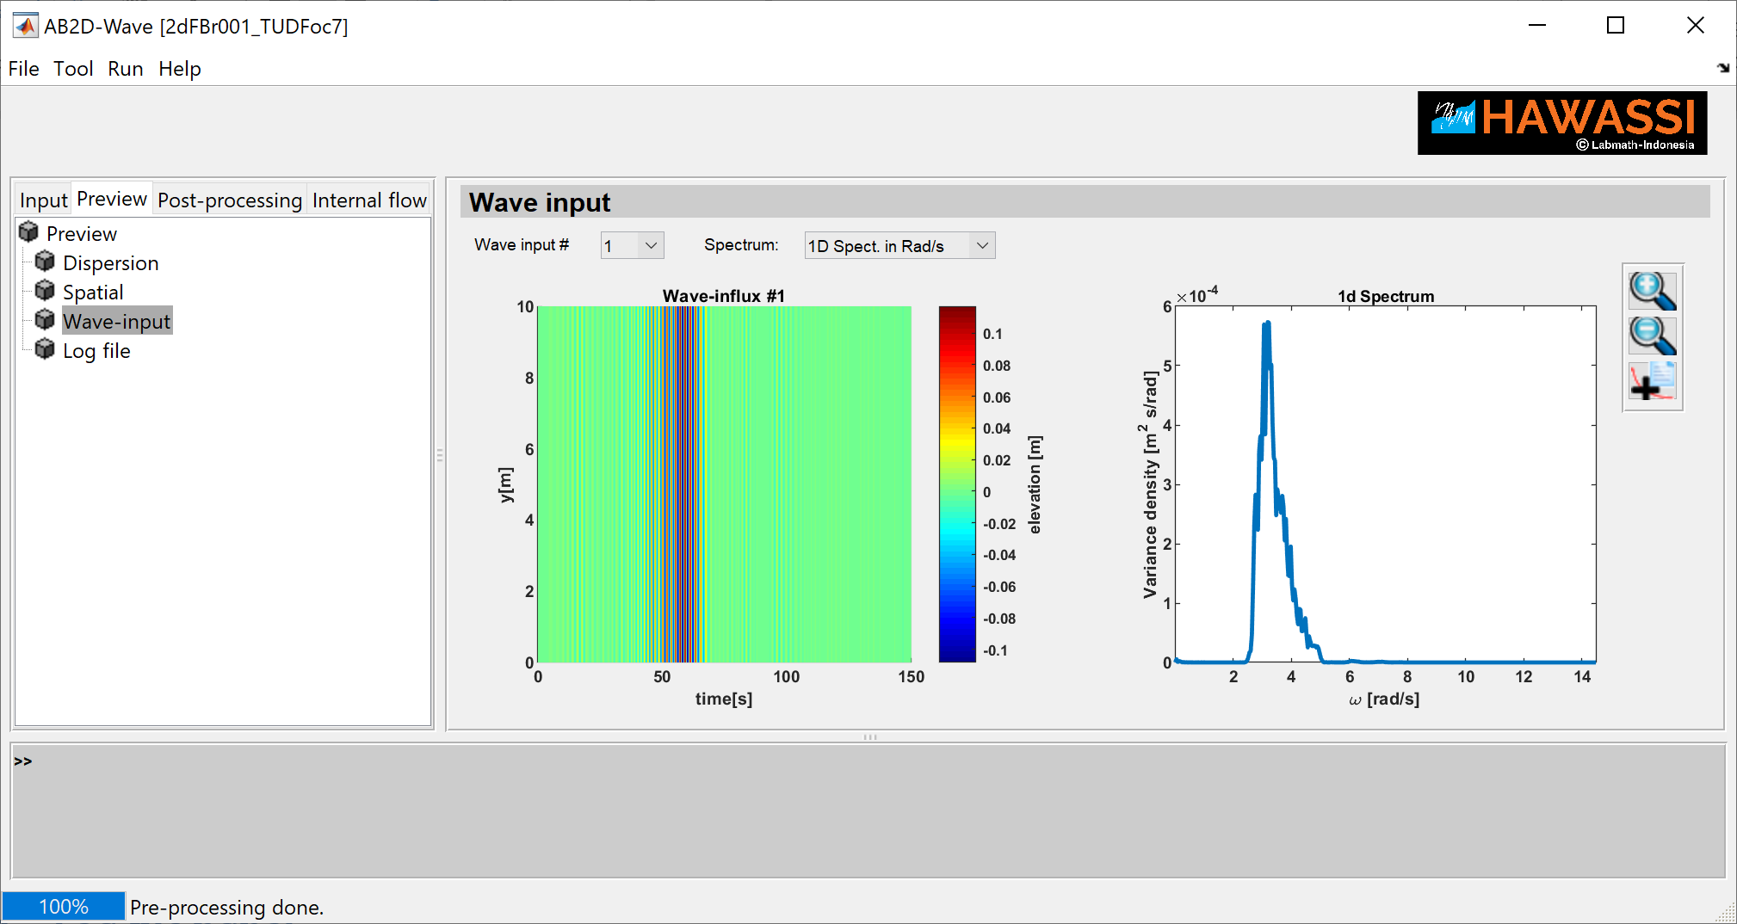

#### Log file panel

The **Log file** panel contains information about the waves to be simulated and details about the geometry and damping zones.

The log-file will be updated after finishing the calculation with info about the computation time.

The log file contains the following information:

* The date and time of creation
* The project name
* The user note
* Model description: details of the numerical code
* Influx description: details of the given influx.

From that wave information, characteristic quantities (frequency, wave length, phase & group speed, etc) are derived for the waves *at the depth of the influx line*. Note that calculated data may slightly differ from input values because of the statics used to calculate wave length, period etc.

* Initial wave conditions: details of initial wave field.
* Boundary assimilation: details of the method
* Numerical settings: spatial interval, grid sizes, Fourier boundaries, number of nodes, time interval and time step.
* Bathymetry: description, and value of depth(s), and number of depth ref. for the FIO interpolation.
* Wall info: shape, method, type, reflection coefficient.
* Influxing settings: line or area influxing, position of line, time interval of influx, for each influx.
* ODE settings: Solver and relative error tolerance, number of partitions

After a simulation has been finished, and data loaded, added information is given:

* The time of the simulation in seconds ‘timeodesolver’, and the *relative computation time* ‘CompRel’, which is the fraction of the time needed for the simulation divided by the length of the time interval.

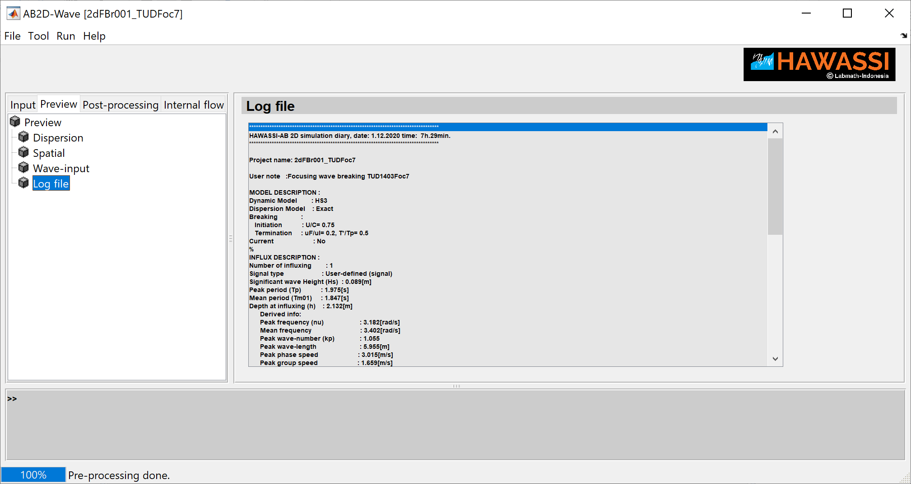

After the set-up is checked in the preview panels, pressing **RUN** and choice of **Start simulation** will initiate the calculation of the time integration (i.e. solving the ODE).

At the lower part of the bottom, the *progress of the simulation* is shown, with estimates for the remaining time needed to finish the simulation. Note that initially the *estimated time* may be too optimistic, for instance when complicated geometries make difficult nonlinear waves for which smaller internal ode-time steps are required. Also for partitioned simulations, the data processing (storing to disk and combining partitions) may take some additional time.

### Post-processing

For **Post-processing** various panels are available, named **Project, Plotting, Quantitative, Animation and Validation.** The description of the panels is as follows.

#### Project panel

In the **project** panel, a **project directory**, **simulation data**, **project name** and a **user note** are automatically specified after the ODE calculation is finished. The user can change the specified input in the panel.

Previously obtained simulation data of this or other projects (format: *projectname_simul*) can be loaded for further post-processing.

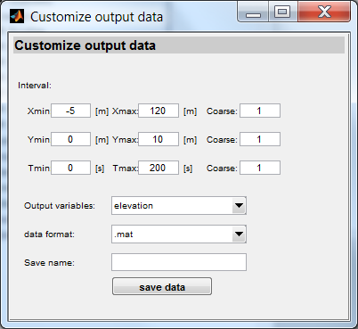In the panel, there is also a facility **Customize data**. The facility is to customize the simulation data such that the domain size, format data are as desired by a user. The customized data will be saved in the Project director with a name as specified save name.

There the spatial settings, the time interval and the grid size can be adjusted by the user. Wave elevation, wave potential or all data can be choose as output data. The data can be saved as ‘*.txt*’ or ‘*.mat*’.

For ‘*all* data’ output variable, only ‘*.mat*’ format data is available and only this data can be loaded in the GUI for post-processing.

#### Plotting panel

The **Plotting panel** contains two sub-panels: ***Density plots*** and ***Line plots***.

In all sub-panels, facilities for plotting are present:

* A **toolbar** for zoom out, zoom in, a data cursor, rotation and panning a view of the graph.
* **Plot setting** is to adjust **view, clim, xlim, ylim** and various other quantities.
  + **View**  is a specifies the point of view in the format [*az;el*] or just a number 2 or 3.

The azimuth, *az,* in degrees isthe horizontal rotation about the *z*-axis; the vertical elevation of the view point, *el*, is also in degrees.

Input view 2 sets two-dimensional view, [*az;el*]=[0;90], while input view 3 sets three-dimensional view, [*az;el*]=[-37.5;30].

* + **Clim, Xlim and Ylim** restrict the interval for the color bar and for the *x* and *y* axes, respectively. The input format is [*min val*; *max val*].
  + 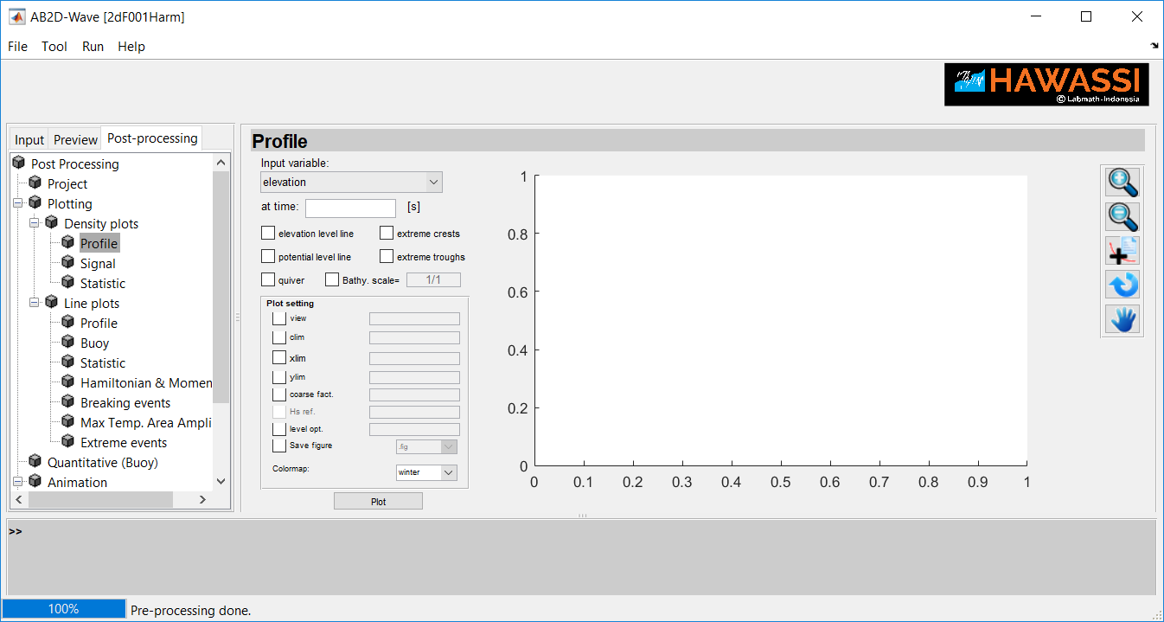**Coarse fact** is a factor to coarsen the spatial or time grid size.

(Be aware that coarsening will change the quality of time traces or profiles, spectra, etc, and may influence the results when validating with external measurements.)

* + **Save figure** or **save data** isan optionfor saving aplot/data in the working directory.
* Moreover,
  + In the panels under **‘*Density plots*’**, a choice from three colour maps is available: ‘winter’, ‘jet’and ‘gray’.
  + In the sub-panel ‘***Extreme events***’ there is an option to define what ‘extreme’ means by specifying the value ***Hs*. ref** that has to be exceeded.

By default, the calculated significant wave height, *Hs,* is used as the reference value.

* + In the sub panel **‘*Density plots - Profile*’** level lines can beadded to density plots. With **Level opt** is an option to restrict the values of level lines.

The input format is an integer or exact values of the contour.

An integer specifies the number of level lines; the software then chooses the correct values. Exact values of the level lines can be specified as [*val 1; val 2; val 3;* … ]; the number of contour lines is then the same as the length of the specified input.

One exact value for only one level line can be specified as [*val 1; val 1*].

* **Plotting panels**
  + 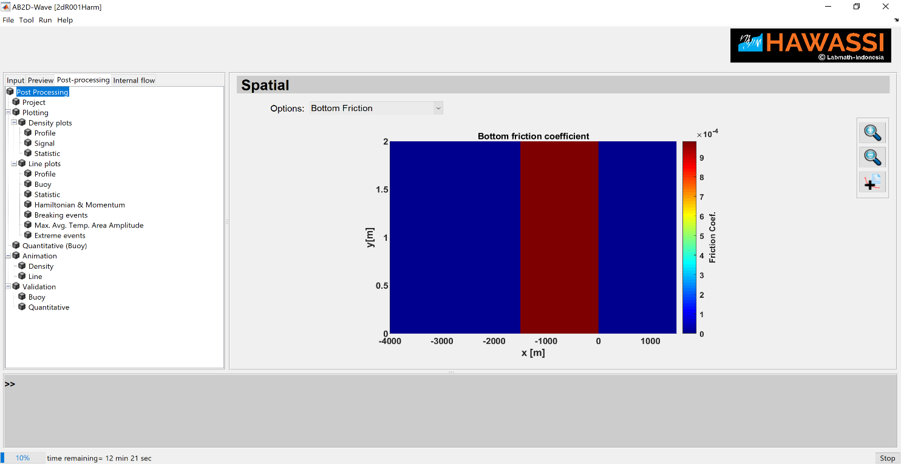**A *density plot* or *a* *line plot* of a *profile* and *Buoy***show the plot of (multiple) wave profile(s)/time-signal(s) at specified time(s)/ position(s), with various options to include level line, spectra, MTA (maximal temporal crests and troughs) and bathymetry.
  + The ***Statistic*** panel shows density or line plot of **significant wave height** (*Hs*), ***Maximum Water Level*** (*MWL*), ***Maximum Temporal Crest*** (*MTC*), ***Minimal Temporal Trough*** (*MTT*),  
    **and Average Temporal Crest (ATC) and Trough (ATT).**

In addition line plots are available for the **peak period** (*Tp*), ***skewness*** (*Sk*), ***asymmetry*** (*As*), **kurtosis** (*Ku*), c**rest and trough exceedance** and **elevation exceedance**. The definition of the quantities is described below.

* + A line plot of the ***Hamiltonian*** (total energy) and ***Momentum*** shows the potential, kinetic and total energy and momentum as function of time. This calculation is available for a post-processing after *run simulation*, but it will not be available for a post-processing from a loaded simulation data which has no velocity data.
  + The ***Breaking events*** plots shows the positions (*x,y*) and time of breaking events The kinematic shows the maximum particle velocity at the crest (*U*) and the instantaneous crest speed (*C*).
  + ***Maximal Temporal Area Amplitude* and *Average Temporal Area Amplitude*** shows a plot of the maximal and average area amplitude, the maximal temporal amplitude function of *x* or *y* and *x-y-t* position of maximal crest and trough. The plot maximal/average area or temporal amplitude consist two plots: maximal/average area/temporal crest and minimal/average area/temporal trough.
  + ***Extreme events*** shows the plot of position and event time of extreme crests or troughs. An extreme condition is defined as crest or trough height larger than a reference value. By default, the significant wave height of the initial wave input is used as the reference value. The user can specify the *Hs* reference in the plot setting panel.

#### Quantitative (Buoy) panel

**Quantitative (Buoy)** is used to analyse simulated results of time signals at specified positions.

The quantities are *Hs, Max* Crest*, Min* Trough*, Mean* Elevation*, Tp,* mean period *Tm01, Skewness, Asymmetry* and *Kurtosis,* see below.

For more than one buoy, the locations are specified as [*x1,x2,x3,…*] and [*y1,y2,y3,…*].

There is also the option to combine time signals and calculate the values for the combined signal.

#### Animation panel

Animation of ***Density*** or ***Line*** plots of wave elevation or potential with various options to include bathymetry, level line and indication of extreme events. The animations can be saved in *.gif* format.

#### Validation panel

Using ***Validation*** simulation results can be compared graphically and quantitatively with known experimental data or other simulations at a specific place (Bouy).

For comparing the time signals spectra, there is the option of **Time shifting** the simulated signal to obtain best comparison; using default (**def**) the best shift is automatically chosen, but the user can also specify the number of time steps.

In subpanel ***Quantitative*** information is provided as the quotient of various quantities of the simulated and the measured data.

#### Definitions of statistics parameters

For a signal *s(t)* with zero-mean, < > denotes time averaging, and *H()* denotes the Hilbert transform in the following.

* + ***Significant wave height*** ($H_{s}$), **Skewness** ($Sk$), ***Asymmetry*** ($As$) and ***Kurtosis*** ()

, , ,

,

* + The ***mean period*** is defined with the variance density spectrum $E(ω)$ as
$$T_{m01}={2π ∫E\left(ω\right)dω}/{\left[∫ωE\left(ω\right)dω\right]}$$

* The ***maximum/Average area/temporal crest (MAC/MTC and AAC/AMC)*** *and* ***maximum/Average area/temporal trough*** are definedwith the elevation $η(x,y,t)$ as

$$MAC\left(t\right)=\max_{\begin{aligned}x∈\left(x_{1},x_{N}\right) \\ y∈\left(y_{1},y_{N}\right)\end{aligned}}\left(η\left(x,y,t\right)\right); MAT\left(t\right)=\min_{\begin{aligned}x∈\left(x_{1},x_{N}\right) \\ y∈\left(y_{1},y_{N}\right)\end{aligned}}\left(η\left(x,y,t\right)\right)$$

$$MTC\left(x\right)=\max_{\begin{aligned}t∈\left(t_{1},t_{N}\right) \\ y∈\left(y_{1},y_{N}\right)\end{aligned}}\left(η\left(x,y,t\right)\right); MTT\left(x\right)=\min_{\begin{aligned}t∈\left(t_{1},t_{N}\right) \\ x∈\left(x_{1},x_{N}\right)\end{aligned}}\left(η\left(x,y,t\right)\right)$$

Similarly defined above for the MTC and MTT as a function of *y* ***and for Averaged quantities***.

* The ***Crest or trough exceedance*** probability is defined as the fraction of number of crests or troughs in a time signal or combined time signals for which the elevation exceeds $αH_{s}$ (with $α$ predefined constants). In default the $H_{s}$ is calculated by the software but user can specify the reference value.
  + The ***Elevation exceedance*** probability is the fraction of the area at which the elevation exceeds $αH_{s}$ averaged over time.
  + The ***correlation*** of a simulated signal *s(t)* and a measured signal *m(t)* is

$$corr\left(s,m\right)={〈s⋅m〉}/{\sqrt{〈s^{2}〉⋅〈m^{2}〉 }}$$

### Internal Flow

For **Post-processing** various panels are available, named **Project, Calculation, Plotting.** The description of the panels is as follows.

#### Project panel

In the **project** panel, a **project directory**, **simulation data**, **project name** and a **user note** are automatically specified after the ODE calculation is finished. The user can change the specified input in the panel.

Previously obtained simulation data of this or other projects (format: *projectname_simul_Interior2D*) can be loaded for further post-processing.

#### Calculation panel

In the calculation panel, the 3D kinematics, that are velocities, accelerations and pressures, are calculated for given user-input of time and spatial intervals by providing initial, final values and step value of the intervals. The vertical spatial interval (z) are user-specified for equidistant or non-equidistant interval. The equidistant interval is calculated from user input of number z point discretization. The non-equidistant interval is user specified z-points or in various interval with MATLAB format i.e $z_{1}:dz_{1}:z_{2}, z_{3}:dz_{2}:z_{4}$.

ID data file is user input integer for giving ID of the saved calculated data. The output file will be saved in the working directory with format: *projectname*_*calc_Interior2D*_*IDdatafile.*

Previously obtained kinematics data of this or other projects (format: *projectname*_calc_Interior2D_*IDdatafile*) can be loaded for further post-processing.

#### Plotting panel

**Plotting panel is for showing density plots and animations. A *density plot*** shows a kinematic property at specified spatial or temporal cross-section, with option to include level line. An animation shows a dynamic of the density plot of a kinematic property for a choice of spatial cross-section. Plot setting is same as in **section 4.3.3.2.**

## lay-out of user defined input files

User input of data-files for various purposes need to be prepared with extension *[.mat, .txt or .dat]* with a format as specified below.

All given spatial and temporal input variables will be interpolated to the grid specified by the user for the numerical simulation. Hence, for example, for repeated simulations with changed grids, the input files do not have to changed.

If the prescribed data covers area of spatial/time domain smaller than the simulation domain, the quantity in the uncovered prescribed data will be set to zero (for bottom friction) or will be set to a nearest values (for bathymetry, time signal, initial wave profile).

### Boundaries

Input files for a user-defined shape of a ***wall*** or ***Fourier boundary*** have the same format:

|  |  |
| --- | --- |
| x1 | y1 |
| x2 | y2 |
| x3 | y3 |
| : | : |

A 2-column matrix (*space point x, space point y*)

first column the x-value ([m]),

second column the y-value ([m]).

### Bottom

* ***Bathymetry***

|  |  |  |
| --- | --- | --- |
| x1 | y1 | $$-D_{1}$$ |
| x2 | y2 | $$-D_{2}$$ |
| x3 | y3 | $$-D_{3}$$ |
| : | : |  |

A 3-column matrix (*space point x, space point y, bathymetry*)

with length of row is $Nx ×Ny$ ($Nx$, $Ny$ are number of points in *x*-axis and *y*-axis, respectively).

First column the *x*-value ([m]),

second column the *y*-value ([m]),

third column the corresponding bathymetry ([m]) .

The bathymetry is defined as the negative depth (*D*).

* ***Bottom friction area***

|  |  |
| --- | --- |
| x1 | y1 |
| x2 | y2 |
| x3 | y3 |
| : | : |

A 2-column matrix (*space point x, space point y*)

first column the x-value ([m]),

second column the y-value ([m]).

### Initial wave profile

|  |  |  |  |  |
| --- | --- | --- | --- | --- |
| x1 | y1 | $$η_{1}$$ | $$u_{1}$$ | $$v_{1}$$ |
| x2 | y2 | $$η_{2}$$ | $$u_{2}$$ | $$v_{2}$$ |
| x3 | y3 | $$η_{3}$$ | $$u_{3}$$ | $$v_{3}$$ |
| : | : | : | : | : |

A 5-column matrix (*space point x, space point y, elevation, velocity (in x dir.), velocity (in y dir.)*) or a 4-column matrix (*space point x, space point y, elevation, potential*) **or** 3-column matrix (*space point x, space point y, elevation*) with length of row $Nx ×Ny$.

first column the x-value ([m]),

second column the y-value ([m]),

third column the prescribed elevation ([m]),

fourth column the prescribed velocity (in x direction) ([m/s],

fifth column the prescribed velocity (in y direction) ([m/s].

The initial velocity will be set to zero if only a 3-column matric is prescribed. If 4-column matric is prescribed, the velocity will be calculated by applying the gradient operator to the prescribed potential data.

### Influx

|  |  |  |  |
| --- | --- | --- | --- |
| 0 | x1 | x2 | .. |
| t1 | $$η_{1,1}$$ | $$η_{2,1}$$ |  |
| t2 | $$η_{2,1}$$ | $$η_{2,2}$$ |  |
| : |  |  |  |

* ***User-defined time signal***

A $(Nt+1) ×(Ns+1)$ matrix.

$Nt$ is length of time vector, and $Ns$ is length of spatial vector

first column the (equidistant) time [s],

first row the (equidistant) spatial (in x or y axes) [m],

[row, column]=[2:end, 2:end], the corresponding elevation, $η$, [m].

|  |  |
| --- | --- |
| $$ω_{1}$$ | $$E_{1}$$ |
| $$ω_{2}$$ | $$E_{2}$$ |
| $$ω_{3}$$ | $$E_{3}$$ |
| : | : |

* ***User-defined variance density spectrum $E(ω)$***

A 2-column matrix ($ω$*, $E(ω)$* )

first column the frequency [rad/s],

second column the variance density spectrum [m2s/rad].

### Boundary assimilation

A $N_{x}$ column matrix with length of row $Ny×Nt+3$. The matrix is illustrated by a table below. In first three rows and three columns, the time and spatial intervals ($t_{start},t_{end}$) [s], ($x_{start},x_{end}$) [m], ($y_{start},y_{end}$) [m] and the number of data, $Nt$, $Nx$, $Ny$ have to be specified. Data of wave elevation, $η$ [m], for $t=t1$ is at column 1 to $Nx$ and row 4 to 4+ $Ny-1$, then followed by the data for $t=t2$ and so on. This format is also applied for input of wave velocity.

|  |  |  |  |  |  |
| --- | --- | --- | --- | --- | --- |
| $$t_{start}$$ | $$t_{end}$$ | $$Nt$$ | 0 | … | 0 |
| $$x_{start}$$ | $$x_{end}$$ | $$Nx$$ | 0 | … | 0 |
| $$y_{start}$$ | $$y_{end}$$ | $$Ny$$ | 0 | … | 0 |
| $$η(t1,y1,x1)$$ | $$η(t1,y1,x2)$$ | $$η(t1,y1,…)$$ | $$η(t1,y1,x4)$$ | $$η(t1,y1,…)$$ | $$η(t1,y1,x_{Nx})$$ |
| $$η(t1,y2,x1)$$ | $$η(t1,y2,x2)$$ | $$η(t1,y2,…)$$ | $$η(t1,y2,x4)$$ | $$η(t1,y2,…)$$ | $$η(t1,y2,x_{Nx})$$ |
| : | : | : | : | : | : |
| $$η(t1,y_{Ny},x1)$$ | $$η(t1,y_{Ny},x2)$$ | … | … | … | $$η(t1,y_{Ny},x_{Nx})$$ |
| $$η(t2,y1,x1)$$ | $$η(t2,y1,x2)$$ | $$η(t2,y1,…)$$ | $$η(t2,y1,x4)$$ | $$η(t2,y1,…)$$ | $$η(t2,y1,x_{Nx})$$ |
| $$η(t2,y2,x1)$$ | $$η(t2,y2,x2)$$ | $$η(t2,y2,…)$$ | $$η(t2,y2,x4)$$ | $$η(t2,y2,…)$$ | $$η(t2,y2,x_{Nx})$$ |
| : | : | : | : | : | : |
| $$η(t2,y_{Ny},x1)$$ | $$η(t2,y_{Ny},x2)$$ | … | … | … | $$η(t2,y_{end},x_{Nx})$$ |
| : | : | : | : | : | : |

### External measurement data

|  |  |  |  |
| --- | --- | --- | --- |
| 0 | $$x_{1}$$ | $$x_{2}$$ | … |
| 0 | $$y_{1}$$ | $$y_{2}$$ | … |
| $$t_{1}$$ | $$η_{1,1}$$ | $$η_{1,2}$$ | … |
| $$t_{2}$$ | $$η_{2,1}$$ | $$η_{2,2}$$ | … |
| : | : | : | … |
| $$t_{end}$$ | $$η_{N_{t},1}$$ | $$η_{N_{t},2}$$ | … |

***Time signals*** at *m* measurement positions. Matrix with (*m+1*) columns:

First row, columns 2 to *m*+1: specify measurement position in x axis ( *position x_1, …, position x_m*)

Second row, columns 2 to *m*+1: specify measurement position in y axis ( *position y_1, …, position y_m*)

Next rows: time and elevation at the measurement positions (*time, elevation_1, …, elevation_m*)

# Test cases

HAWASSI-AB provides 17 Test-cases that are identified with a code of which the first letter has the following meaning:

F: for various cases of non-breaking waves above Flat bottom

B: for various cases of non-breaking waves above non-flat bathymetry

Br: for various cases of breaking waves above flat or varying bottom

R: Run-up on beach

The basic properties of the test cases are listed with references to relevant publications in the next sections.

**Acknowledgements:**

Only by testing with realistic data software can be validated and improved.

We are very grateful to be allowed to use measurement data of

* MARIN (Maritime Research Institute Netherlands), Dr. T. Bunnik
* TUD (Technical University of Delft), Prof.dr. R.H.M. Huijsmans
* Oceanide, Prof. B. Molin
* Authors of publications:
  + Beji & Battjes
    - S. Beji, J. Battjes, Numerical simulation of nonlinear wave propagation over a bar, *Coastal Engineering* 23 (1994) 1 – 16.
    - S. Beji, J. Battjes, Experimental investigation of wave propagation over a bar, *Coastal Engineering* 19 (1993) 151 – 162.
  + Ting& Kirby
    - F. C. Ting, J. T. Kirby, Observation of undertow and turbulence in a laboratory surf zone, Coastal Engineering 24 (1994) 51 – 80.
  + Wei e.a.
    - G. Wei, J. T. Kirby, S. T. Grilli, R. Subramanya, A fully nonlinear Boussinesq model for surface waves. Part 1. Highly nonlinear unsteady waves, *Journal of Fluid Mechanics* 294 (1995) 71–92.
  + Oceanide
    - Y. N. Liu, B. Molin, O. Kimmoun, F. Remy, M.-C. Rouault, Experimental and numerical study of the effect of variable bathymetry on the slow-drift wave response of floating bodies. 2011. *Applied Ocean Research* 33, 199-207

## Non-breaking waves above flat bottom

### 2dF001Harm: Harmonic wave

Dynamic Model : HS1

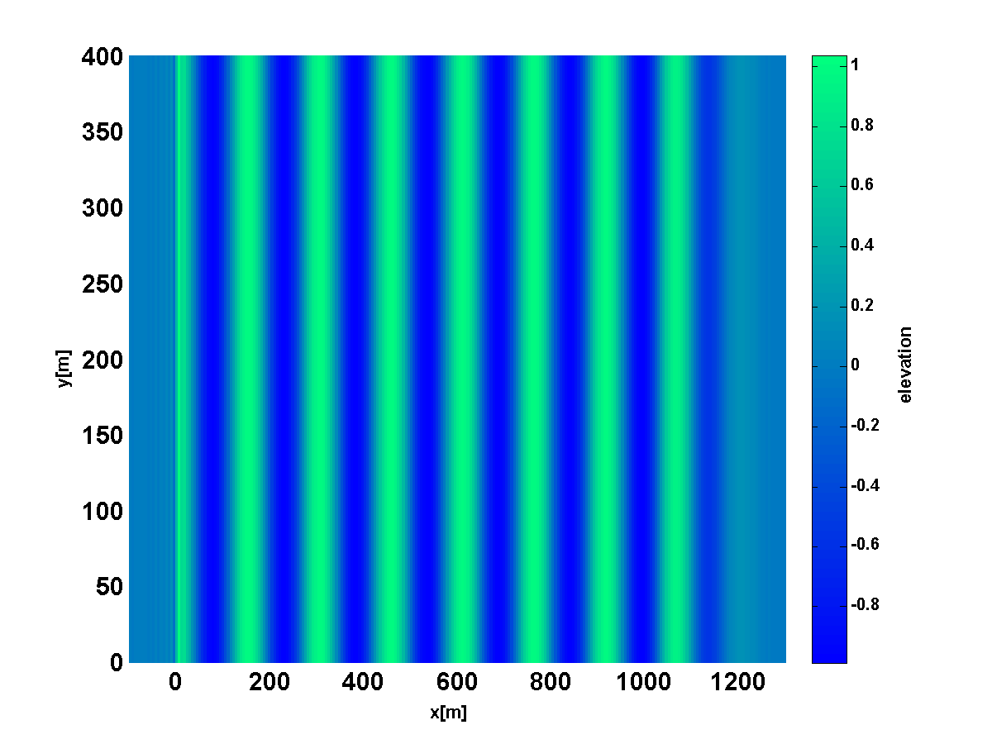

Harmonic wave

Dispersion Model : Exact

Signal type : Harmonic

Amplitude (A) : 1[m]

Peak period (Tp) : 12[s]

**influx**

Mean period (Tm01) : 11.472[s]

Direction (degree) : 0[deg]

Depth at influxing (h) : 20[m]

Derived info:

Peak frequency (nu) : 0.534[rad/s]

Mean frequency : 0.548[rad/s]

Peak wave-number(kp) : 0.042

Peak wave-length : 148.764[m]

Peak phase speed : 12.644[m/s]

Peak group speed : 10.405[m/s]

Steepness (kp*(Hs./2)) : 0.042

Relative wave-length(lambda/h) : 7.4382

(kp*h) : 0.845 (Intermediate depth)

### 2dF002HarmDifrac: Diffracted harmonic wave

Dynamic Model : HS1

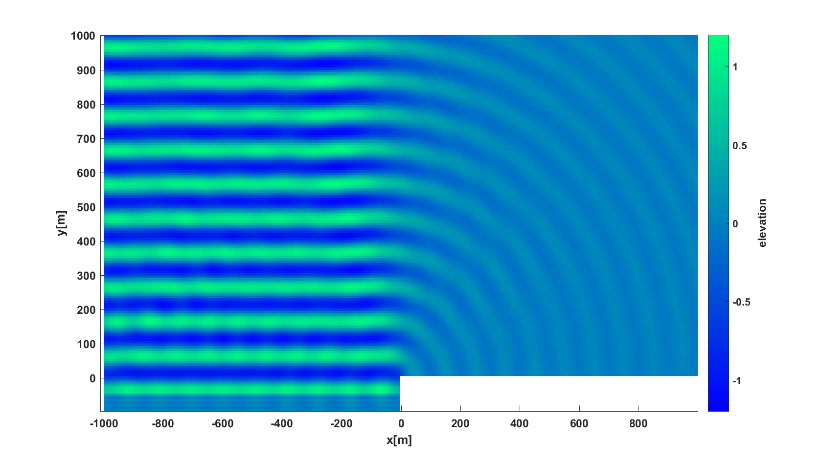

An illustration of the diffraction phenomenon.

Dispersion Model : Exact

**wall**

Signal type : Harmonic

Amplitude (A) : 1[m]

Peak period (Tp) : 10.75[s]

Mean period (Tm01) : 10.826[s]

Direction (degree) : 90[deg]

Depth at influxing (h) : 10[m]

**influx**

**wall**

Derived info:

Peak frequency (nu) : 0.578 [rad/s]

Mean frequency : 0.58 [rad/s]

Peak wave-number(kp) : 0.062

Peak wave-length : 101.534 [m]

Peak phase speed : 9.34 [m/s]

Peak group speed : 8.331 [m/s]

Steepness (kp*(Hs./2)) : 0.062

Relative wave-length(lambda/h) : 10.1534

(kp*h) : 0.619 (Intermediate depth)

### 2dF003Simple_Harbour: Harmonic wave in a rectangular basin

Dynamic Model : HS1

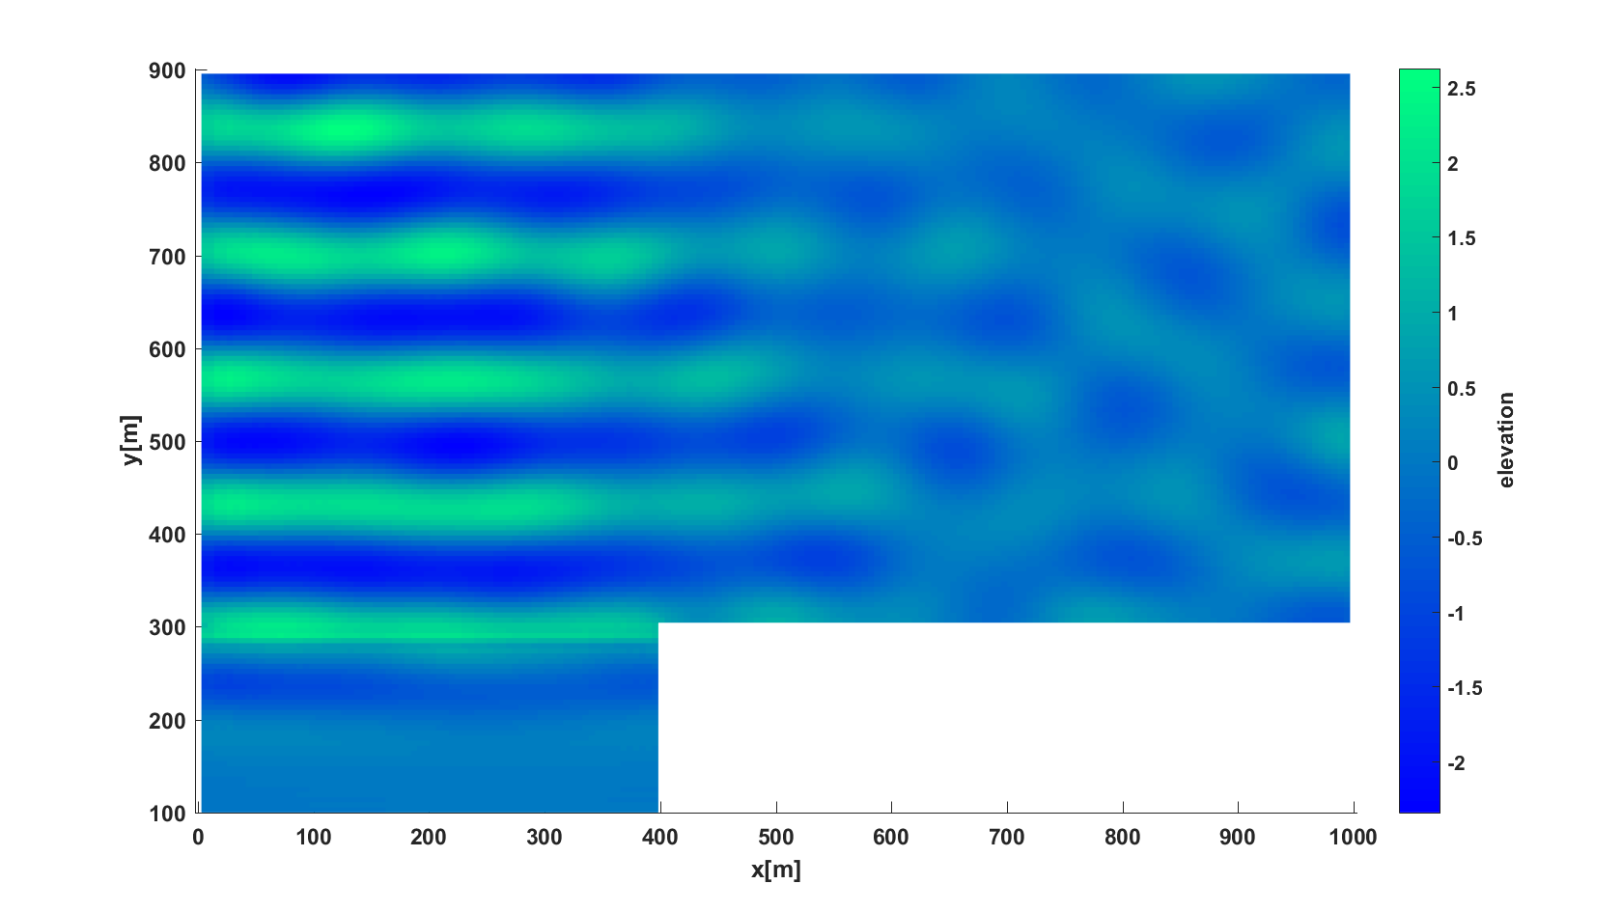

Wave in a rectangular basin

Dispersion Model : Exact

Signal type : Harmonic

Amplitude (A) : 1[m]

Peak period (Tp) : 12 [s]

Mean period (Tm01) : 11.815[s]

Direction (degree) : 90[deg]

Depth at influxing (h) : 15[m]

**influx**

Derived info:

Peak frequency (nu) : 0.528 [rad/s]

Mean frequency : 0.532 [rad/s]

Peak wave-number(kp) : 0.047

Peak wave-length : 134.12 [m]

Peak phase speed : 11.27 [m/s]

Peak group speed : 9.765 [m/s]

Steepness (kp*(Hs./2)) : 0.047

Relative wave-length(lambda/h) : 8.94

(kp*h) : 0.703 (Intermediate depth)

### 2dF004SimpleHarbour

Dynamic Model : HS1

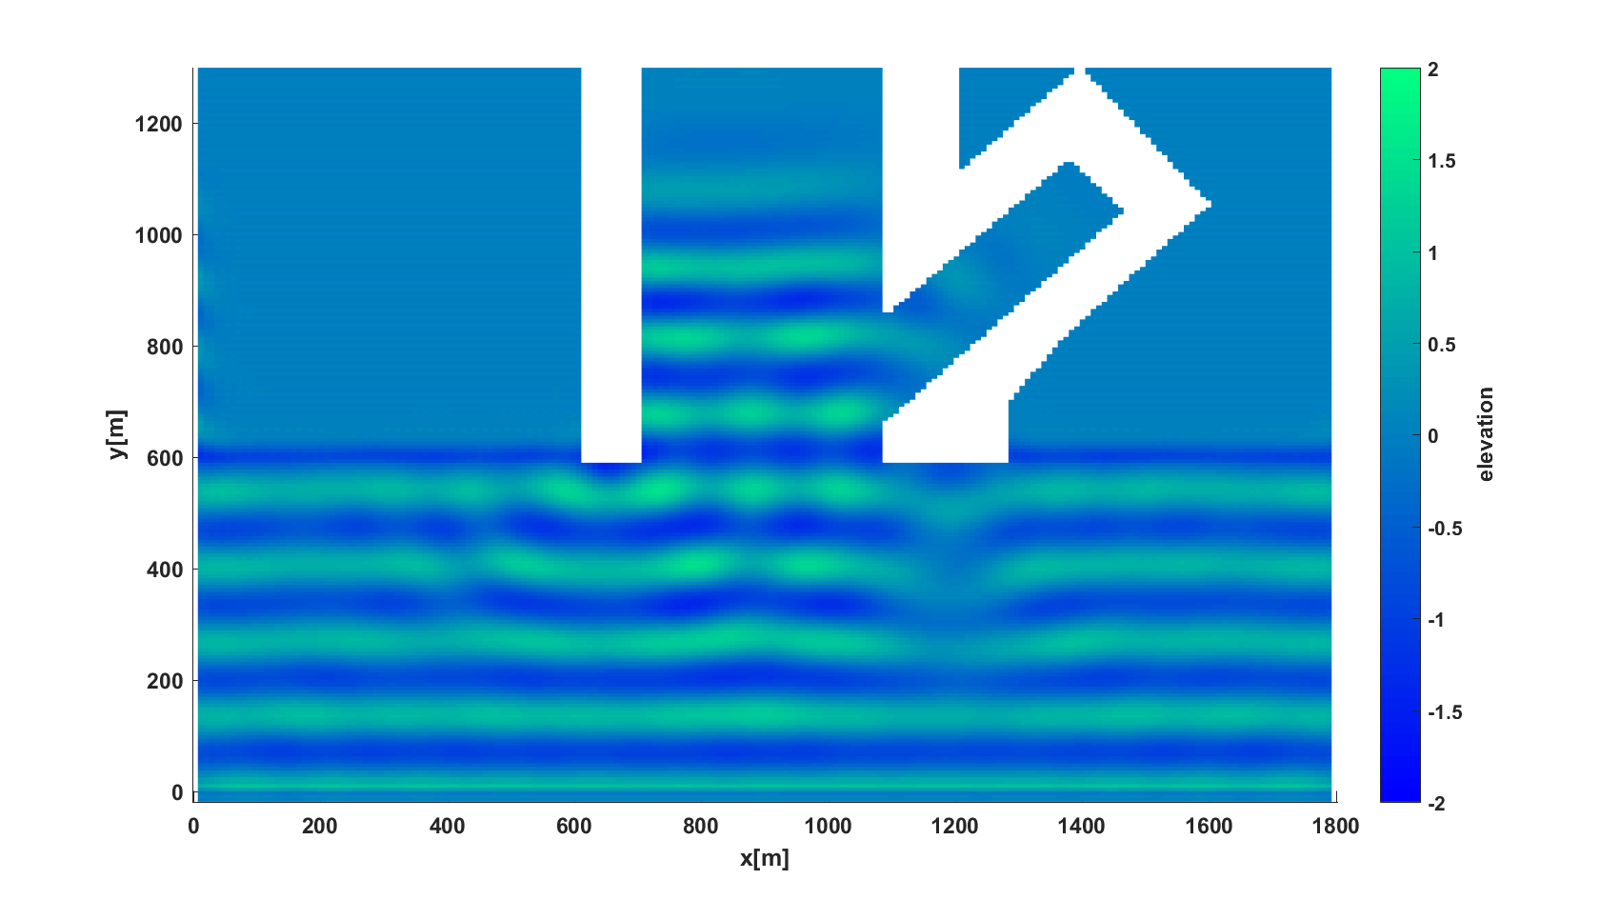

Wave in a harbour

Dispersion Model : Exact

Signal type : Harmonic

Amplitude (A) : 1[m]

Peak period (Tp) : 12 [s]

Mean period (Tm01) : 12[s]

Direction (degree) : 90[deg]

Depth at influxing (h) : 15[m]

Derived info:

Peak frequency (nu) : 0.524 [rad/s]

**influx**

Mean frequency : 0.524 [rad/s]

Peak wave-number(kp) : 0.046

Peak wave-length : 135.37 [m]

Peak phase speed : 11.28 [m/s]

Peak group speed : 9.8 [m/s]

Steepness (kp*(Hs./2)) : 0.046

Relative wave-length(lambda/h) : 9.03

(kp*h) : 0.7 (Intermediate depth)

P.P.D. van der Ven. Benchmark tests of wave penetration in harbours. *Measurement report 1209490-000-HYE-0001.* Deltares. The Netherlands.

### 2dF005SimpleHarbour

Dynamic Model : HS1

Dispersion Model : Exact

**influx**

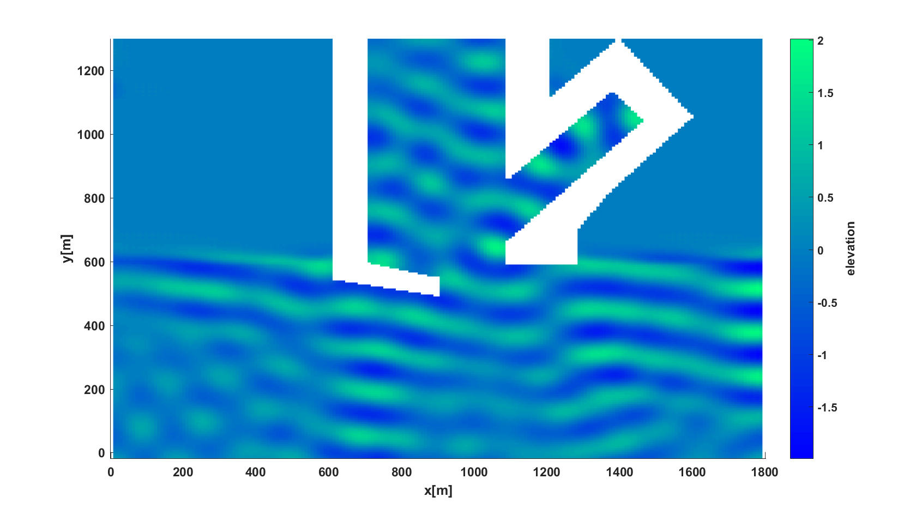

Wave in a harbour

Signal type : Harmonic

Amplitude (A) : 1[m]

Peak period (Tp) : 12[s]

Mean period (Tm01) : 12.001[s]

Direction (degree) : 80[deg]

Depth at influxing (h) : 15[m]

Derived info:

Peak frequency (nu) : 0.524[rad/s]

Mean frequency : 0.524[rad/s]

Peak wave-number (kp) : 0.046

Peak wave-length : 135.364[m]

Peak phase speed : 11.279[m/s]

Peak group speed : 9.799[m/s]

Steepness (kp*(Hs./2)) : 0.046

Relative wave-length(lambda/h) : 9.0243

(kp*h) : 0.696 (Intermediate depth)

P.P.D. van der Ven. Benchmark tests of wave penetration in harbours. *Measurement report 1209490-000-HYE-0001.* Deltares. The Netherlands.

### 2dF006Simple Harbour: Omni direction waves

Dynamic Model : HS1

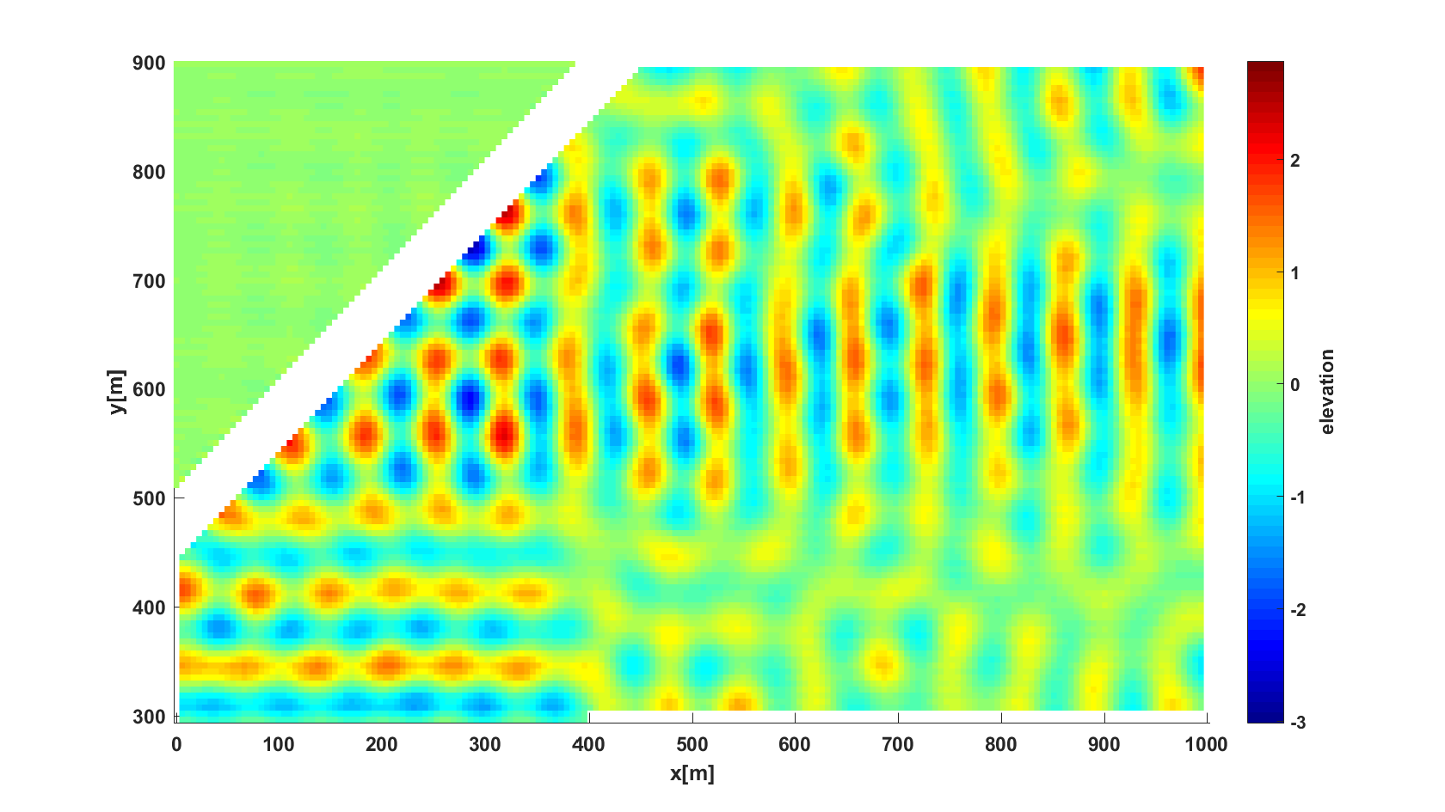Wave in a harbour

Dispersion Model : Exact

Signal type : Harmonic

Amplitude (A) : 1[m]

Peak period (Tp) : 7[s]

Mean period (Tm01) : 7.029[s]

Direction (degree) : 90[deg]

Depth at influxing (h) : 15[m]

Derived info:

**influx**

Peak frequency (nu) : 0.892[rad/s]

Mean frequency : 0.894[rad/s]

Peak wave-number (kp) : 0.092

Peak wave-length : 68.236[m]

Peak phase speed : 9.689[m/s]

Peak group speed : 6.541[m/s]

Steepness (kp*(Hs./2)) : 0.092

Relative wave-length(lambda/h) : 4.5491

(kp*h) : 1.381 (Intermediate depth)

### 2dF007Biharm: Biharmonic wave

Dynamic Model : HS2

Dispersion Model : Exact

Number of influxing : 2

--------------------- Influxing-1---------------------

Signal type : Harmonic

Amplitude (A) : 0.1[m]

Peak period (Tp) : 1.8 [s]

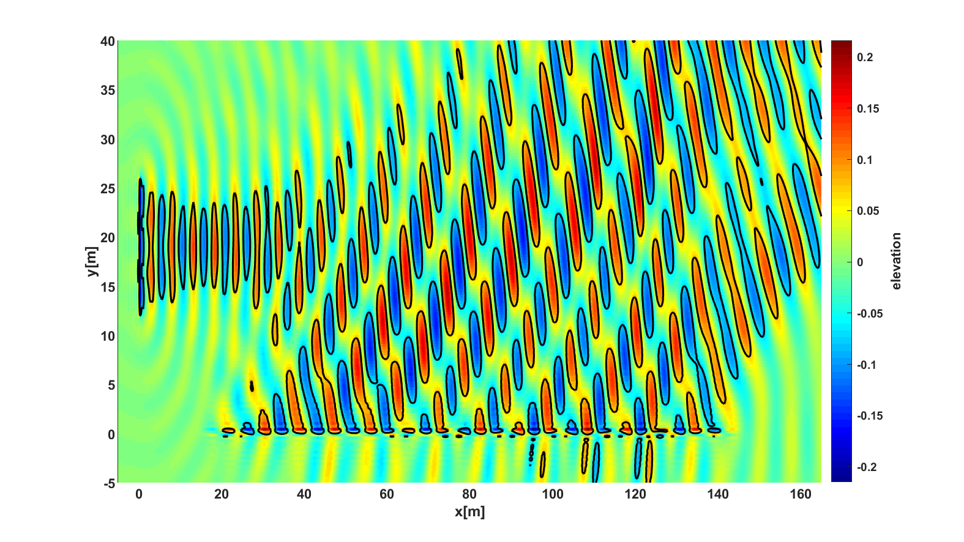

Bi harmonic wave in a wave tank that are generated by two wavemakers. Plots below show comparison of time signals between simulation (red) and measurement (blue) at three different buoy locations.

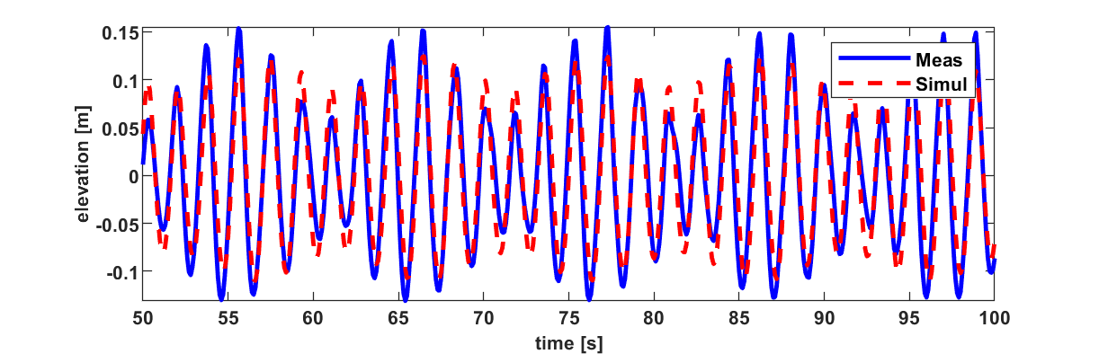

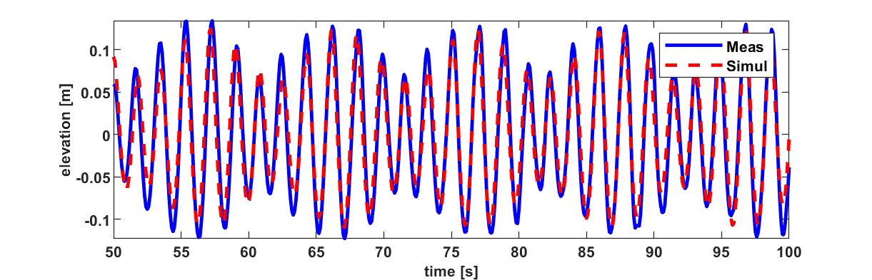

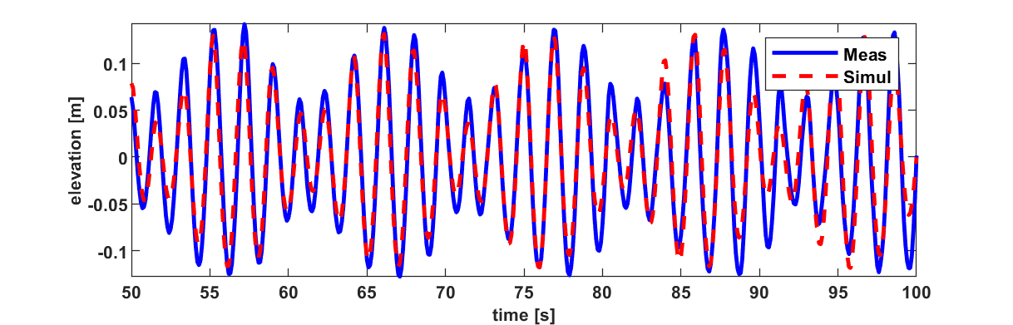

Mean period (Tm01) : 1.78[s]

Direction (degree) : 0[deg]

**Influx 1**

Depth at influxing (h) : 5[m]

Derived info:

Peak frequency (nu) : 3.51 [rad/s]

Mean frequency : 3.53 [rad/s]

**Influx 2**

Peak wave-number(kp) : 1.26

Peak wave-length : 5.01 [m]

Peak phase speed : 2.8 [m/s]

Peak group speed : 1.4 [m/s]

Steepness (kp*(Hs./2)) : 0.125

Relative wave-length(lambda/h) : 1.0

(kp*h) : 6.27 (Deep water)

--------------------- Influxing-2--------------------

Signal type : Harmonic

Amplitude (A) : 0.1[m]

Peak period (Tp) : 2.2 [s]

Mean period (Tm01) : 2.2[s]

Direction (degree) : 30[deg]

Depth at influxing (h) : 5[m]

Derived info:

Peak frequency (nu) : 2.88 [rad/s]

Mean frequency : 2.86 [rad/s]

Peak wave-number(kp) : 0.85

Peak wave-length : 7.43 [m]

Peak phase speed : 3.41 [m/s]

Peak group speed : 1.71 [m/s]

Steepness (kp*(Hs./2)) : 0.085

Relative wave-length(lambda/h) : 1.49

(kp*h) : 4.23 (Deep water)

L. S. Liam, Mathematical modelling of generation and forward dispersive waves. 2013. *Ph.D Thesis University of Twente*

### 2dF008DraupnerSea

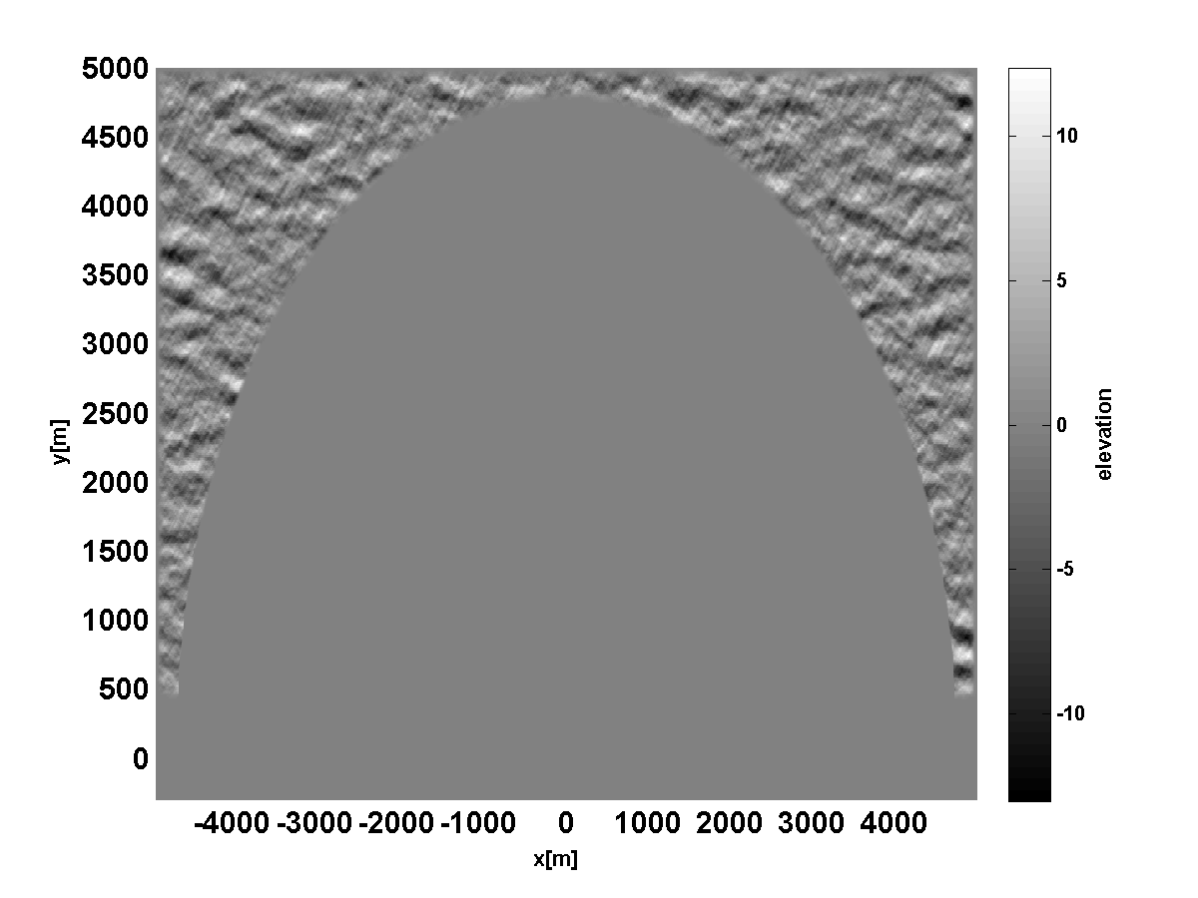

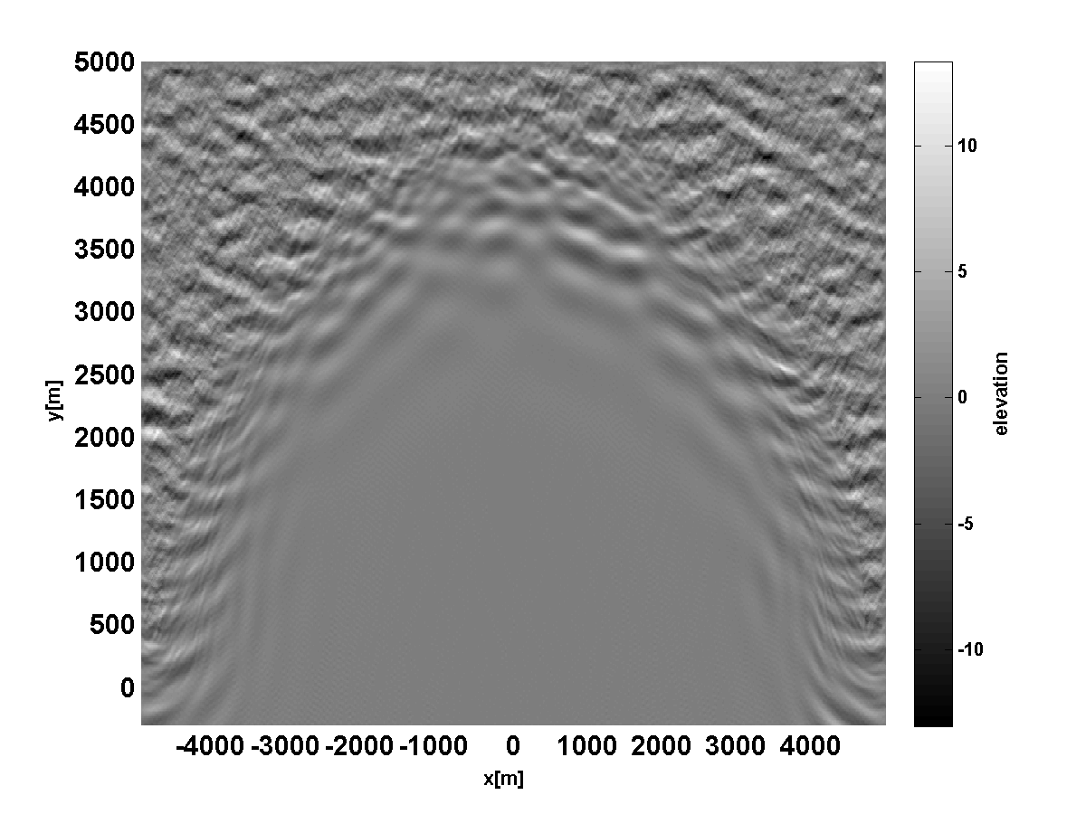

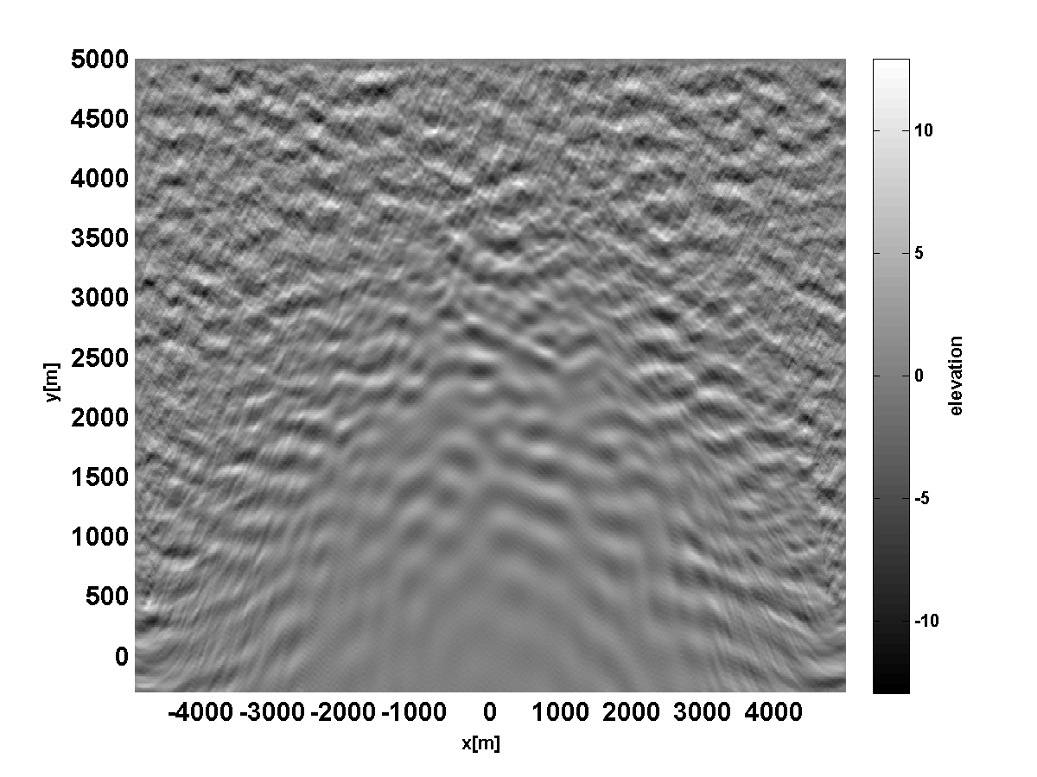

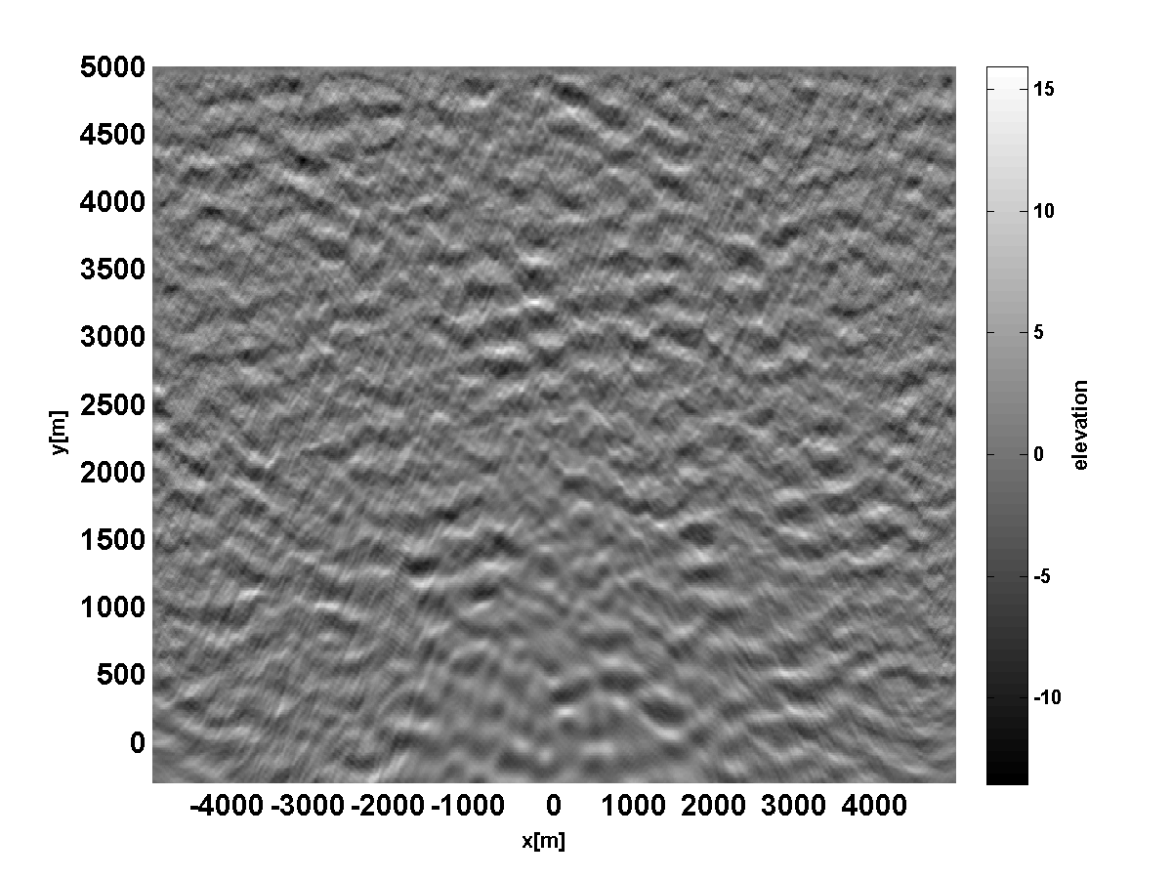

Boundary assimilation method for generating Draupner seas. Figures from top to bottom are density plots of wave elevation at t=0, 100, 250 and 500 s, respectively.

Dynamic Model : HS3

Dispersion Model : Exact

BOUNDARY ASSIMILATION

Shape : Half-circle

at radius :4750 Smooth factor: 10

Center position (x,y)=(0,0) [m]

Propagation direction: South

Significant wave Height : 11.81[m]

Peak period (Tp) : 14.54 [s]

Derived info:

Peak frequency (nu) : 0.43 [rad/s]

Peak wave-number(kp) : 0.021

Peak wave-length : 297.43 [m]

Peak phase speed : 20.5 [m/s]

Peak group speed : 13.4 [m/s]

Steepness (kp*(Hs./2)) : 0.12

Relative wave-length(lambda/h) : 4. 3 (kp*h) : 1.5 (Intermediate depth)

*Note: In the test case, the assimilation data is only up to 15 seconds. For full assimilation data, please ask by sending an email to* [*hawassi@labmath-indonesia.org*](mailto:hawassi@labmath-indonesia.org)*.*

E. van Groesen, P. Turnip & R. Kurnia, High waves in Draupner seas, Part 1: Numerical simulations and characterization of the seas, *J. Ocean Engineering and Marine Energy,* **3** (2017) 233-245

## Breaking waves above flat bottom

### 2dFBr001Foc: Focussing wave

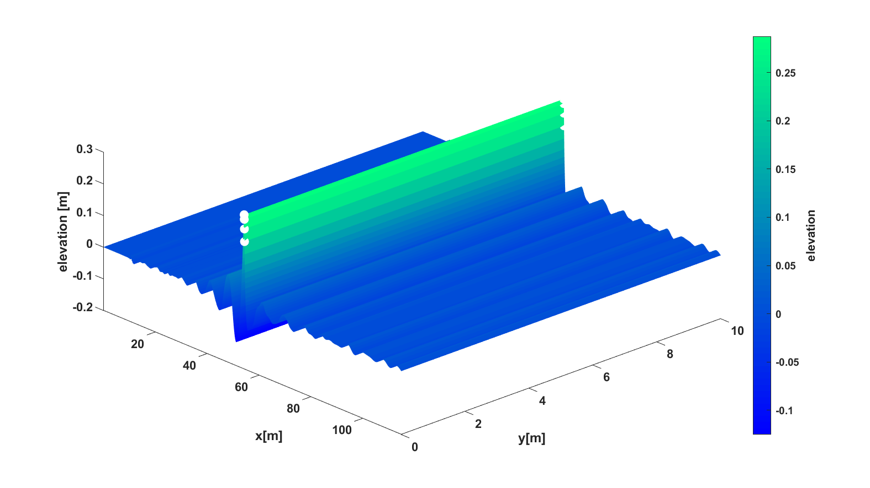

Focussing wave: the top plot shows the wave elevation at t=83.5 s, the middle plot shows a cross section of the internal horizontal velocity at t=83.5, and the plot below is the comparison of the time signal at (x,y)=(65.56, 5) m between simulation (red) and measurement (blue) .

Dynamic Model : HS3

Dispersion Model : Exact

Signal type : User-defined

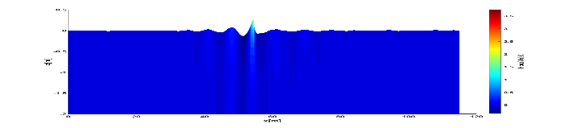Significant wave height : 0.096[m]

Peak period (Tp) : 1.97 [s]

Mean period (Tm01) : 1.85[s]

Depth at influxing (h) : 2.132[m]

Derived info:

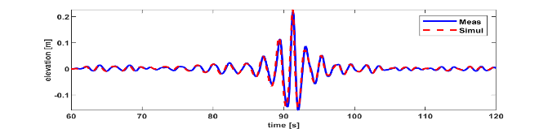Peak frequency (nu) : 3.19 [rad/s]

Mean frequency : 3.4 [rad/s]

Peak wave-number(kp) : 1.06

Peak wave-length : 5.93 [m]

Peak phase speed : 3.01 [m/s]

Peak group speed : 1.6 [m/s]

Steepness (kp*(Hs./2)) : 0.051

Relative wave-length(lambda/h) : 2.78

(kp*h) : 2.2(Intermediate depth)

R. Kurnia, et. al. Simulations for design and reconstruction of breaking waves in a wavetank. In

*ASME 34th International Conference on Ocean, Offshore and Arctic Engineering (OMAE),*

*St John’s, NL, Canada*. ASME, 2015.

### 2dFBr002_Irreg: Irregular wave

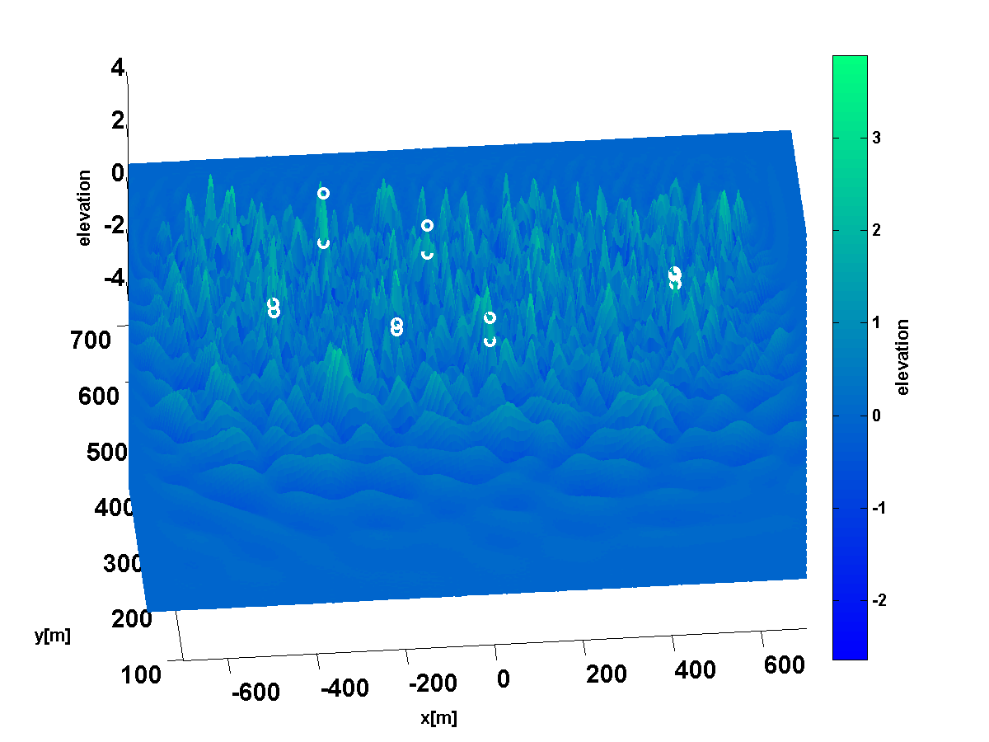

Irregular wave

Dynamic Model : HS2

Dispersion Model : Exact

Signal type : Jonswap

Gamma : 3.3

Spread. Factor : 3

Std. dev : 21.92

Significant wave height : 3 [m]

Peak period (Tp) : 5 [s]

Mean period (Tm01) : 4.17[s]

Direction (degree) : 270 [deg]

Depth at influxing (h) : 40[m]

Derived info:

Peak frequency (nu) : 1.26 [rad/s]

Mean frequency : 1.5 [rad/s]

Peak wave-number(kp) : 0.16

Peak wave-length : 39 [m]

Peak phase speed : 7.81 [m/s]

Peak group speed : 3.9 [m/s]

Steepness (kp*(Hs./2)) : 0.24

Relative wave-length(lambda/h) : 0.98

(kp*h) : 6.44 (Deep water)

## Non-breaking waves above non-flat bathymetry

### 2dB001HarmRefr: Refracted harmonic wave

Bathymetry

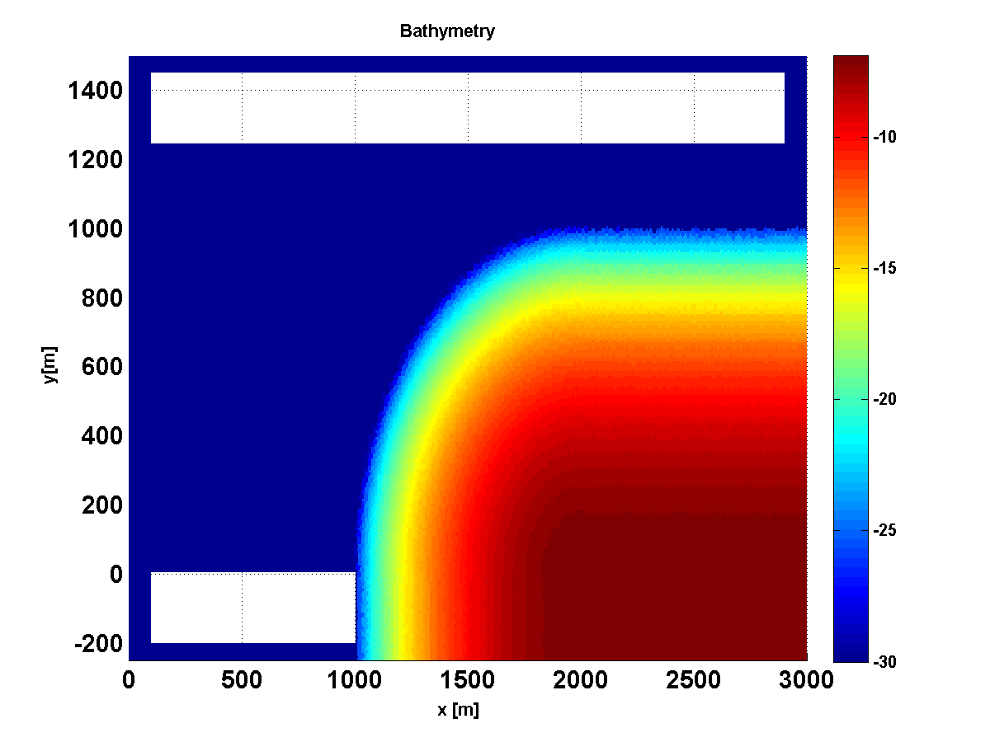

Elevation @ t=300s

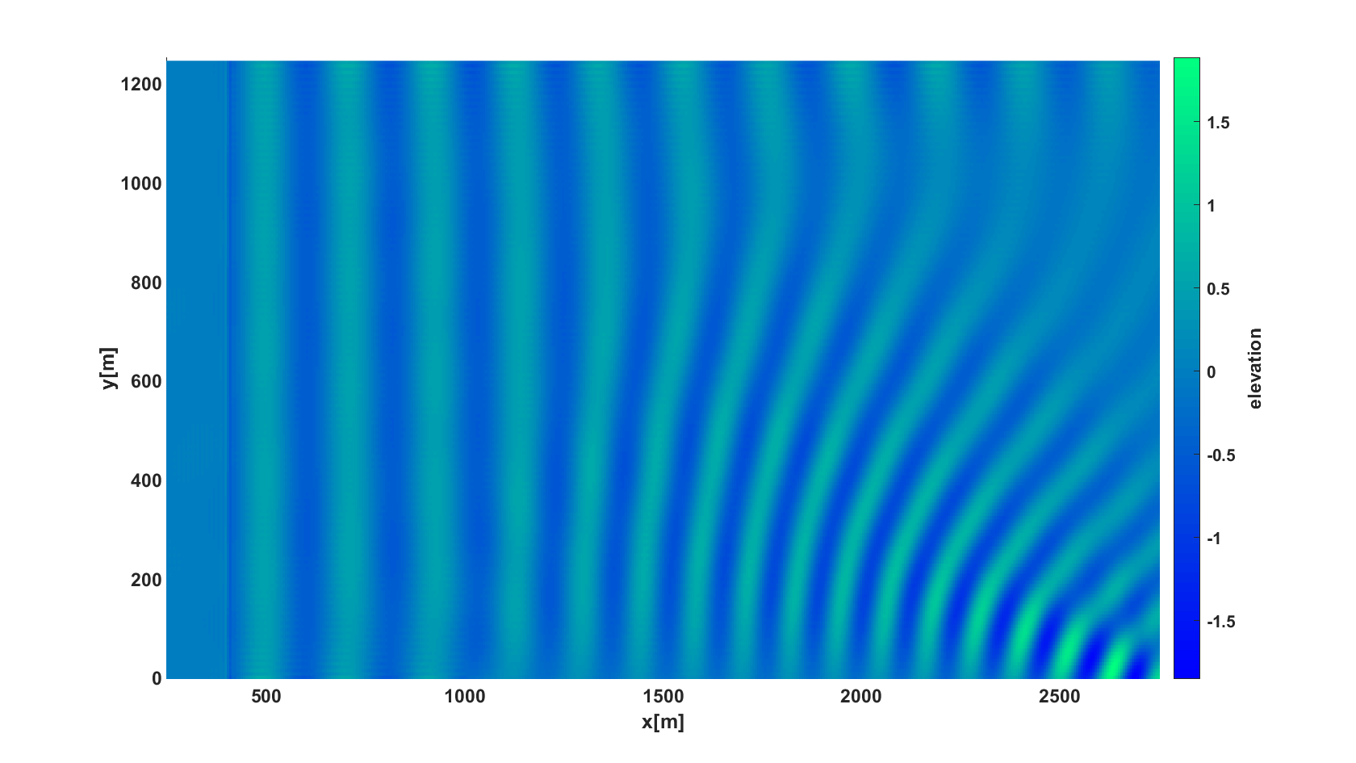

Dynamic Model : HS1

Dispersion Model : Exact

Signal type : Harmonic

Amplitude (A) : 0.5[m]

Peak period (Tp) : 14 [s]

Mean period (Tm01) : 13.6[s]

Direction (degree) : 0[deg]

Depth at influxing (h) : 30[m]

Derived info:

Peak frequency (nu) : 0.456 [rad/s]

Mean frequency : 0.462 [rad/s]

Peak wave-number(kp) : 0.03

Peak wave-length : 211.51 [m]

Peak phase speed : 15.33 [m/s]

Peak group speed : 12.40 [m/s]

Steepness (kp*(Hs./2)) : 0.015

Relative wave-length(lambda/h) : 7.05

(kp*h) : 0.89 (Intermediate depth)

### 2dB002HarmShoaling

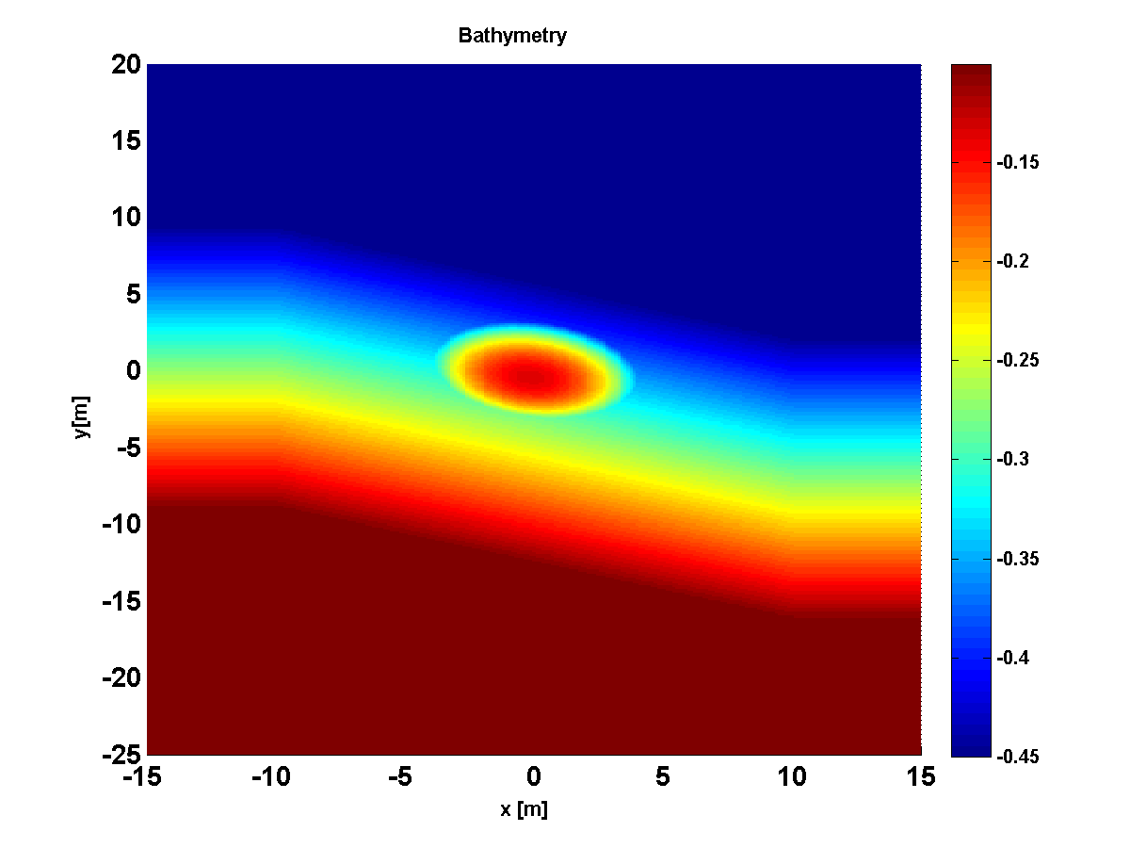

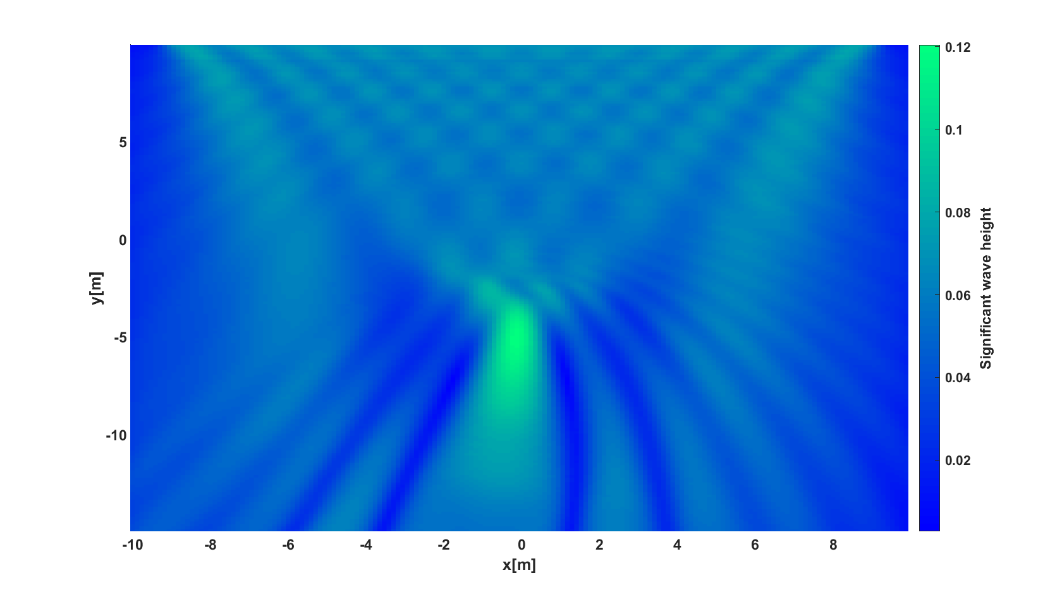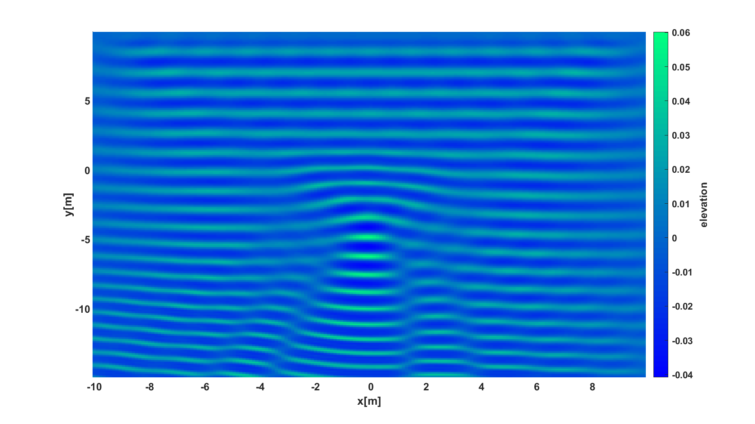

Top: bathymetry, middle: calculated significant wave height for time interval: (0;60) s , below: wave elevation at t=60 s.

Dynamic Model : HS2

Dispersion Model : Exact

Signal type : Harmonic

Amplitude (A) : 0.023[m]

Peak period (Tp) : 1 [s]

Mean period (Tm01) : 1[s]

Direction (degree) : 270[deg]

Depth at influxing (h) : 0.45[m]

Derived info:

Peak frequency (nu) : 6.28 [rad/s]

Mean frequency : 6.28 [rad/s]

Peak wave-number(kp) : 4.21

Peak wave-length : 1.49 [m]

Peak phase speed : 1.49 [m/s]

Peak group speed : 0.87 [m/s]

Steepness (kp*(Hs./2)) : 0.098

Relative wave-length(lambda/h) : 3.32

(kp*h) : 1.89 (Intermediate depth)

Berkhoff, J.C.W., 1982. Refraction and diffraction of water waves: wave deformation bya shoal. *Rept. W. 154-VIII, Delft Hydraulics Laboratory*.

### 2dB003AccessChannel

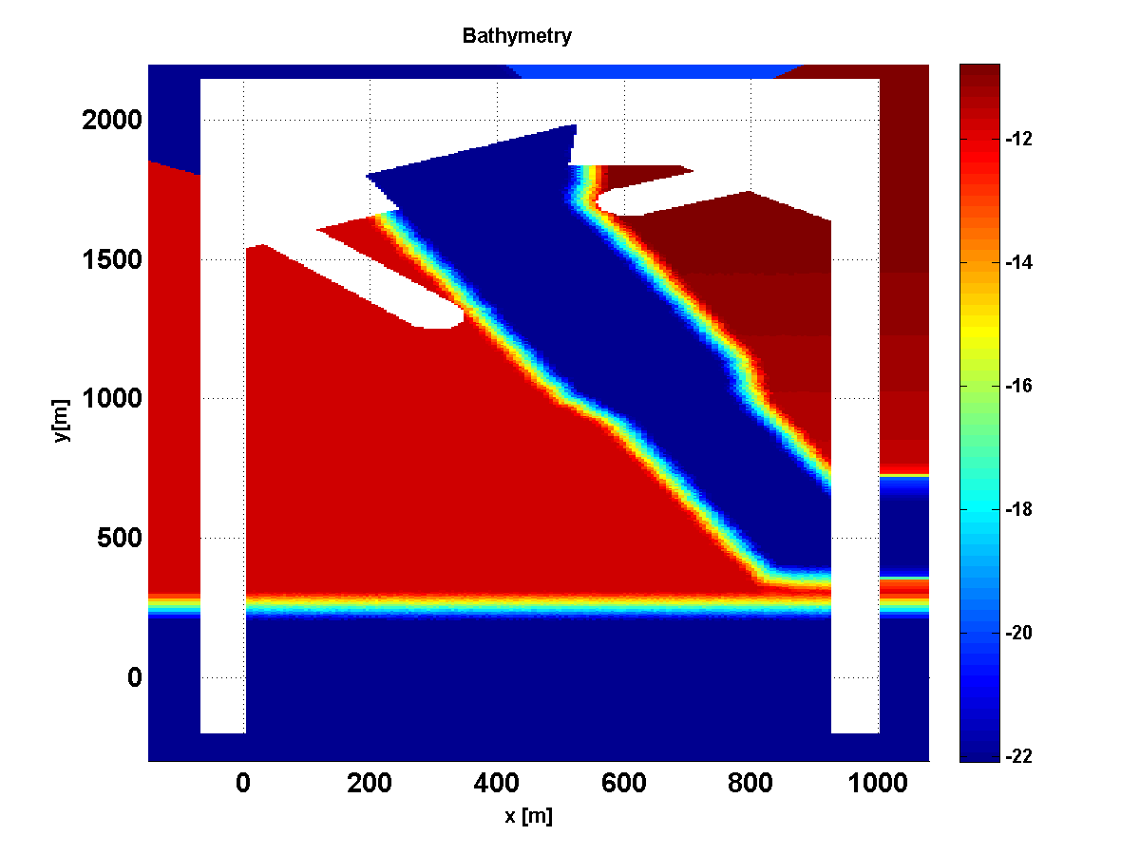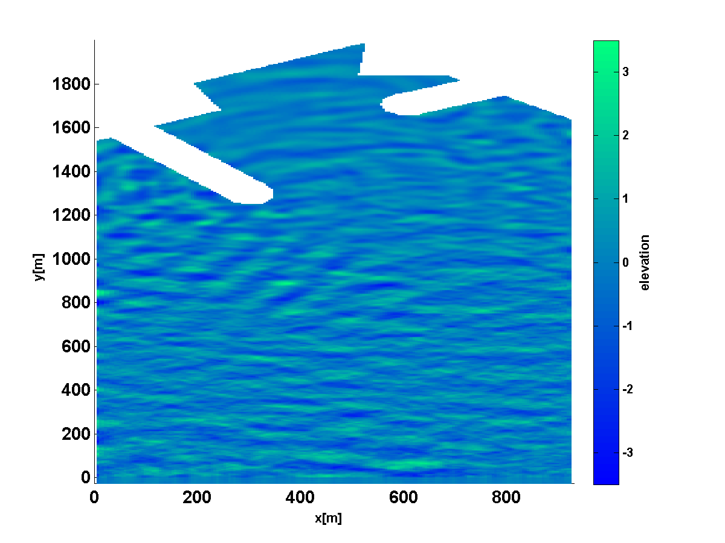

Left: bathymetry: blue= 21, m, red=11 m

Right: density plot of wave elevation at t=430s.

Dynamic Model : HS1

Dispersion Model : Exact

Signal type : User-defined

Significant wave height : 3[m]

Peak period (Tp) : 9.42 [s]

Mean period (Tm01) : 6.25[s]

Depth at influxing (h) : 22.1[m]

Derived info:

Peak frequency (nu) : 0.67 [rad/s]

Mean frequency : 1.01 [rad/s]

Peak wave-number(kp) : 0.06

Peak wave-length : 115.6 [m]

Peak phase speed : 12.27 [m/s]

Peak group speed : 8.83 [m/s]

Steepness (kp*(Hs./2)) : 0.08

Relative wave-length(lambda/h) : 5.23

(kp*h) : 1.20 (Intermediate depth)

R. Kurnia, M.R. Badriana & E. van Groesen, Hamiltonian Boussinesq simulation for waves entering a harbour with access channel, *J. Waterway, Port, Coastal, Ocean Eng.* (2018) 144(2):04017047 1-14

## Breaking waves above bathymetry

### 2dBBr001_HarmBr_BB93

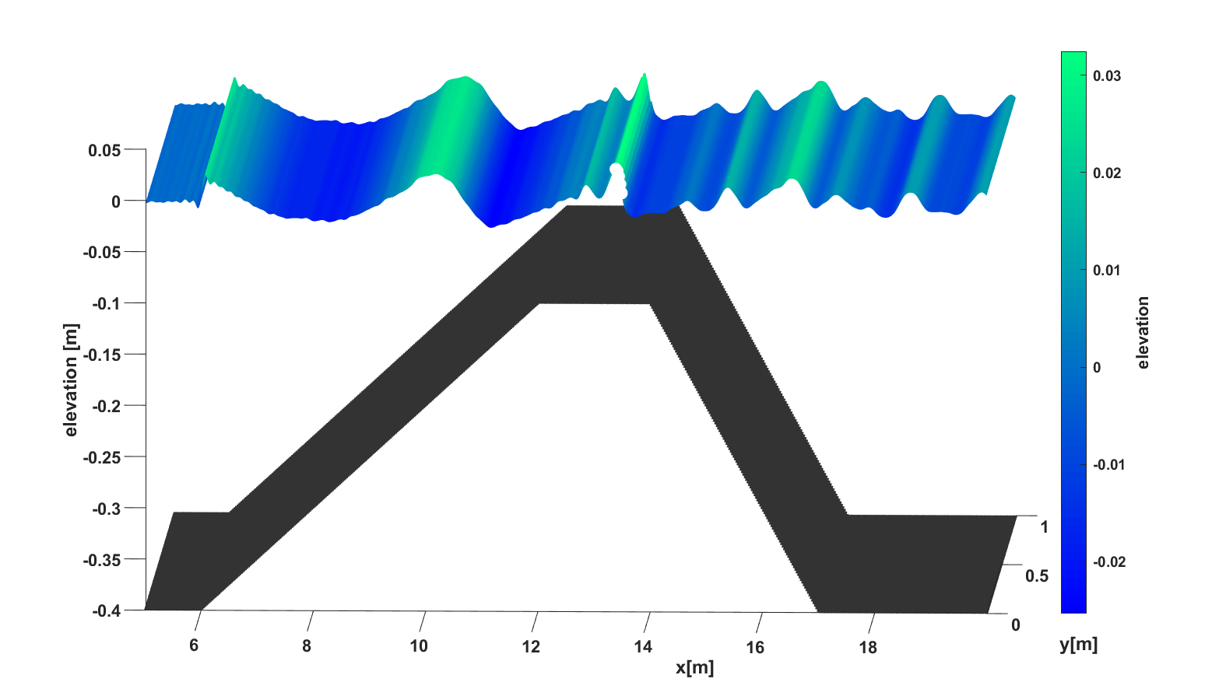

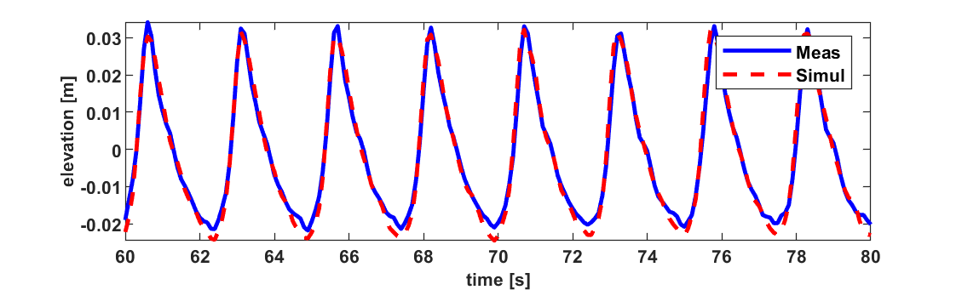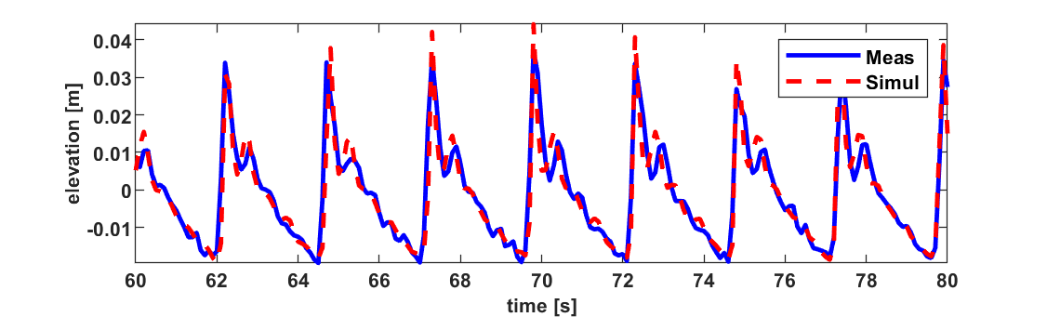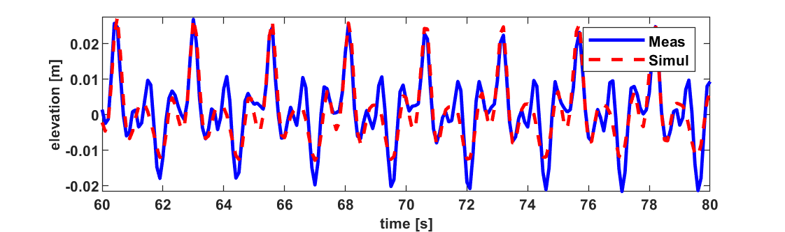

Top: Wave profile at t=55s above bathymetry. Lower Plots from top to bottom are wave signals comparison between measurement (blue) and simulation (red) for buoys at (x,y)=(11,0), (13,0) and (17,0) [m].

Dynamic Model : HS3

Dispersion Model : Exact

Signal type : User-defined

Significant wave height : 0.06[m]

Peak period (Tp) : 2.5 [s]

Mean period (Tm01) : 2.4 [s]

Direction (degree) : 270 [deg]

Depth at influxing (h) : 0.4 [m]

Derived info:

Peak frequency (nu) : 2.5 [rad/s]

Mean frequency : 2.6 [rad/s]

Peak wave-number(kp) : 1.3

Peak wave-length : 4.7 [m]

Peak phase speed : 1.9 [m/s]

Peak group speed : 1.74 [m/s]

Steepness (kp*(Hs./2)) : 0.04

Relative wave-length(lambda/h) : 11.9

(kp*h) : 0.53 (Intermediate depth)

R. Kurniaand E. van Groesen. High order Hamiltonian water wave models with wave breaking mechanism . *Coastal Engineering*, 93(0):55 – 70, 2014.

### 2dBBr002Ir

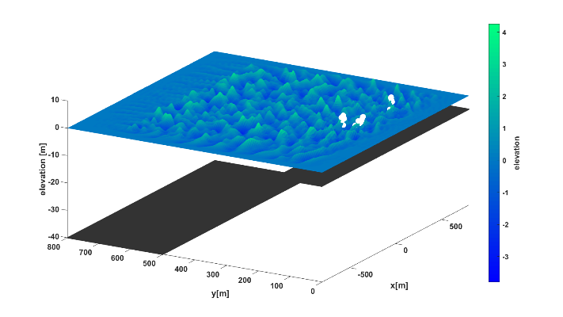

Dynamic Model : HS3

Dispersion Model : Exact

Signal type : Jonswap

Gamma : 3.3

Spread. Factor : 3

Std. dev : 20.5

Significant wave height : 4 [m]

Peak period (Tp) : 7 [s]

Mean period (Tm01) : 5.85[s]

Direction (degree) : 270 [deg]

Depth at influxing (h) : 40[m]

Derived info:

Peak frequency (nu) : 0.9 [rad/s]

Mean frequency : 1.07[rad/s]

Peak wave-number(kp) : 0.08

Peak wave-length : 76 [m]

Peak phase speed : 10.9 [m/s]

Peak group speed : 5.5 [m/s]

Steepness (kp*(Hs./2)) : 0.17

Relative wave-length(lambda/h) : 1.9

(kp*h) : 3.3 (Deep water)

## Wave runup on shore

### 2dR001Harm

Dynamic Model : HS3

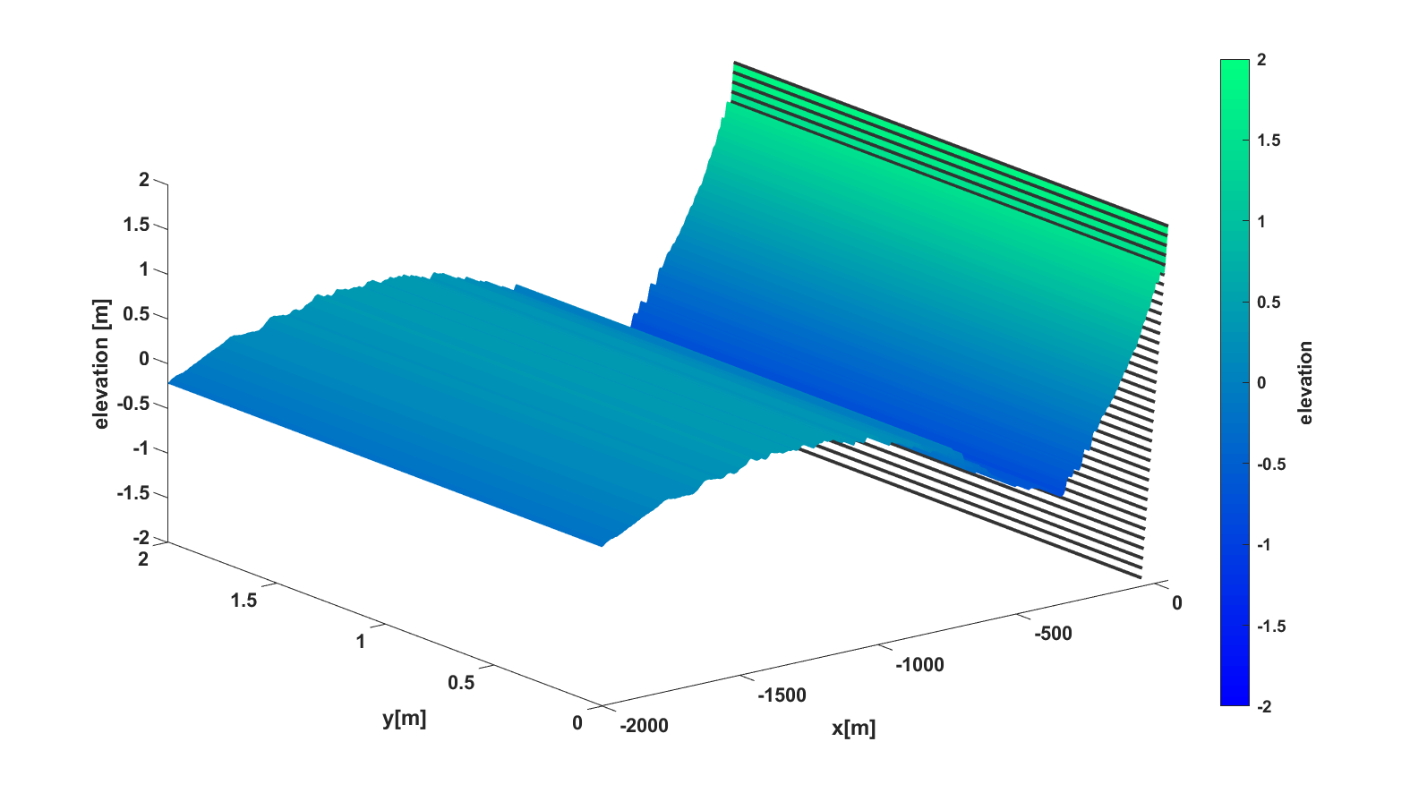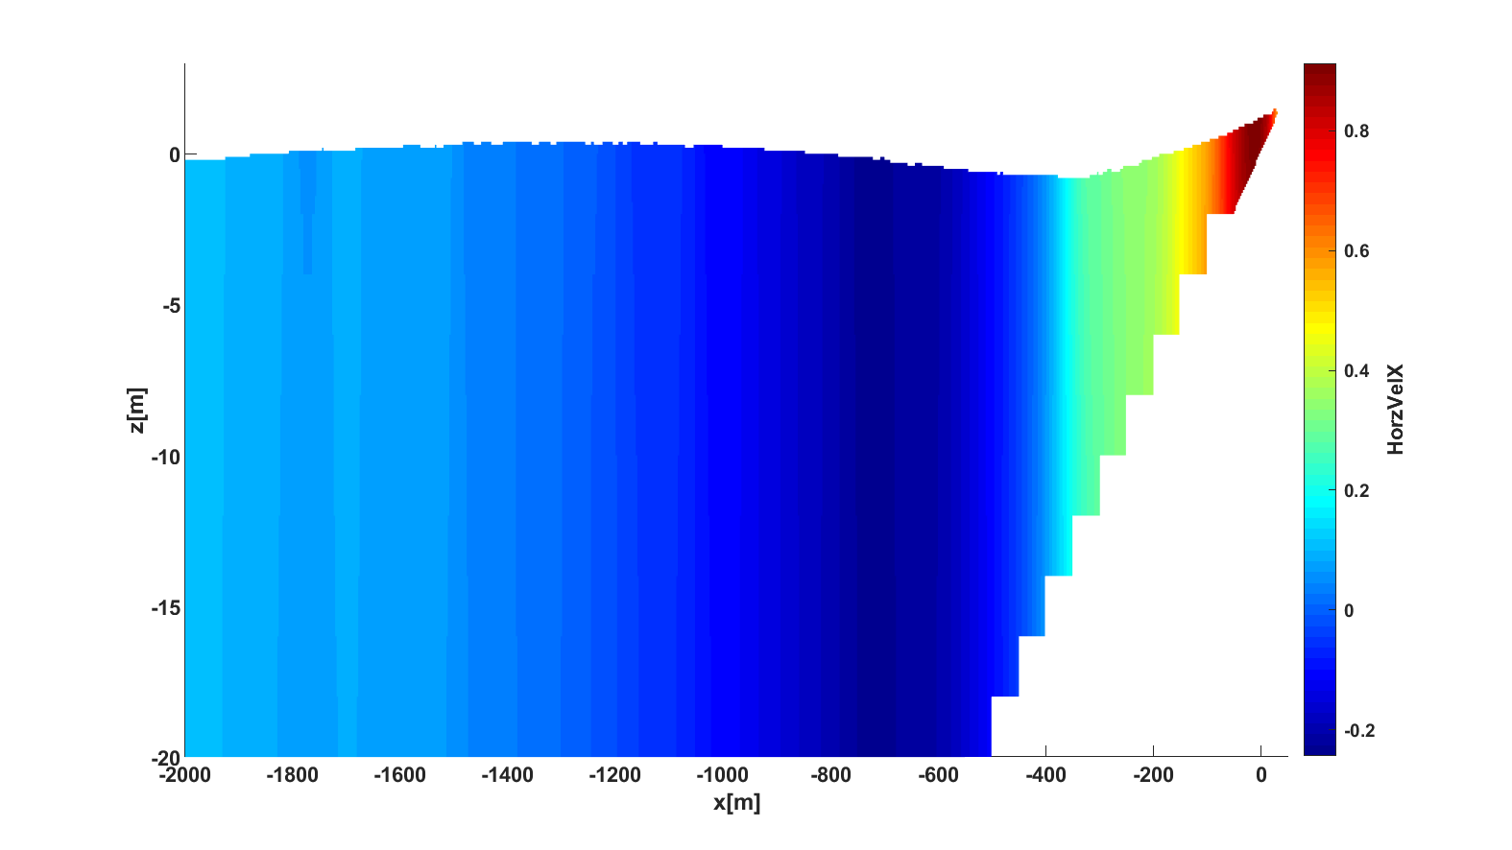

Wave runup on a shore. Top plot show wave elevation at time t=770 s, and lower top shows a cross section of internal horizontal velocity.

Dispersion Model : Exact

Signal type : Harmonic

Amplitude (A) : 0.3[m]

Peak period (Tp) : 100[s]

Mean period (Tm01) : 100.005[s]

Direction (degree) : 0[deg]

Depth at influxing (h) : 50[m]

Derived info:

Peak frequency (nu) : 0.063[rad/s]

Mean frequency : 0.063[rad/s]

Peak wave-number (kp) : 0.003

Peak wave-length : 2207.407[m]

Peak phase speed : 22.073[m/s]

Peak group speed : 21.925[m/s]

Steepness (kp*(Hs./2)) : 0.001

Relative wave-length(lambda/h): 44.1481(Shallow water)

(kp*h) : 0.142

## Breaking wave runup on shore

### 2dRBr001_MoLiu_IR2

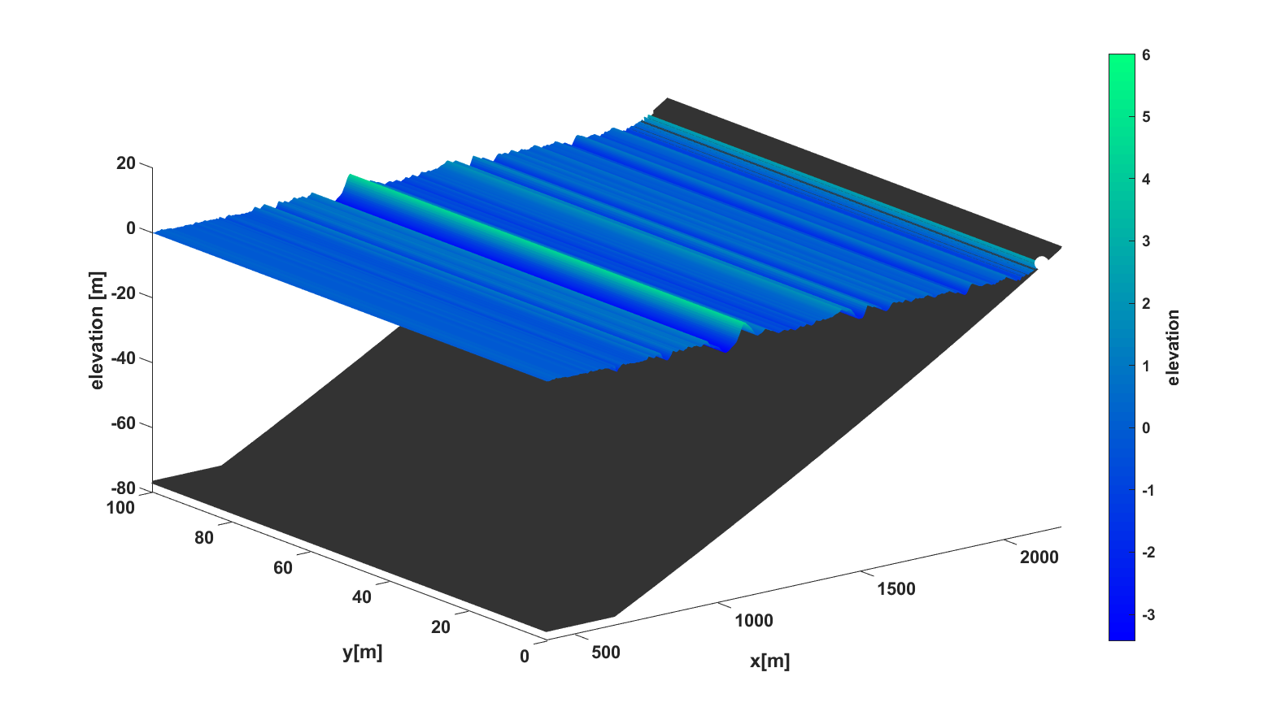

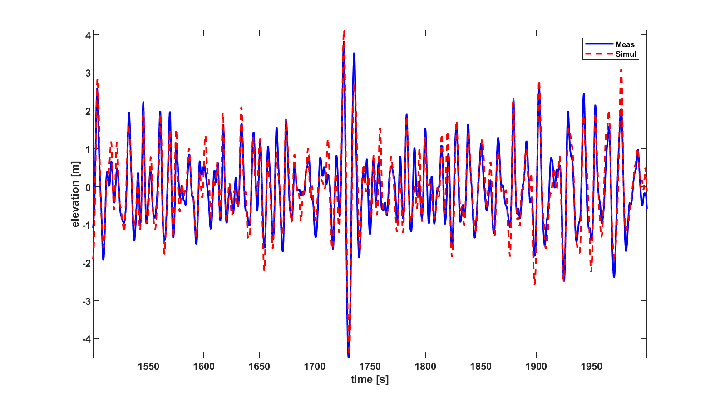

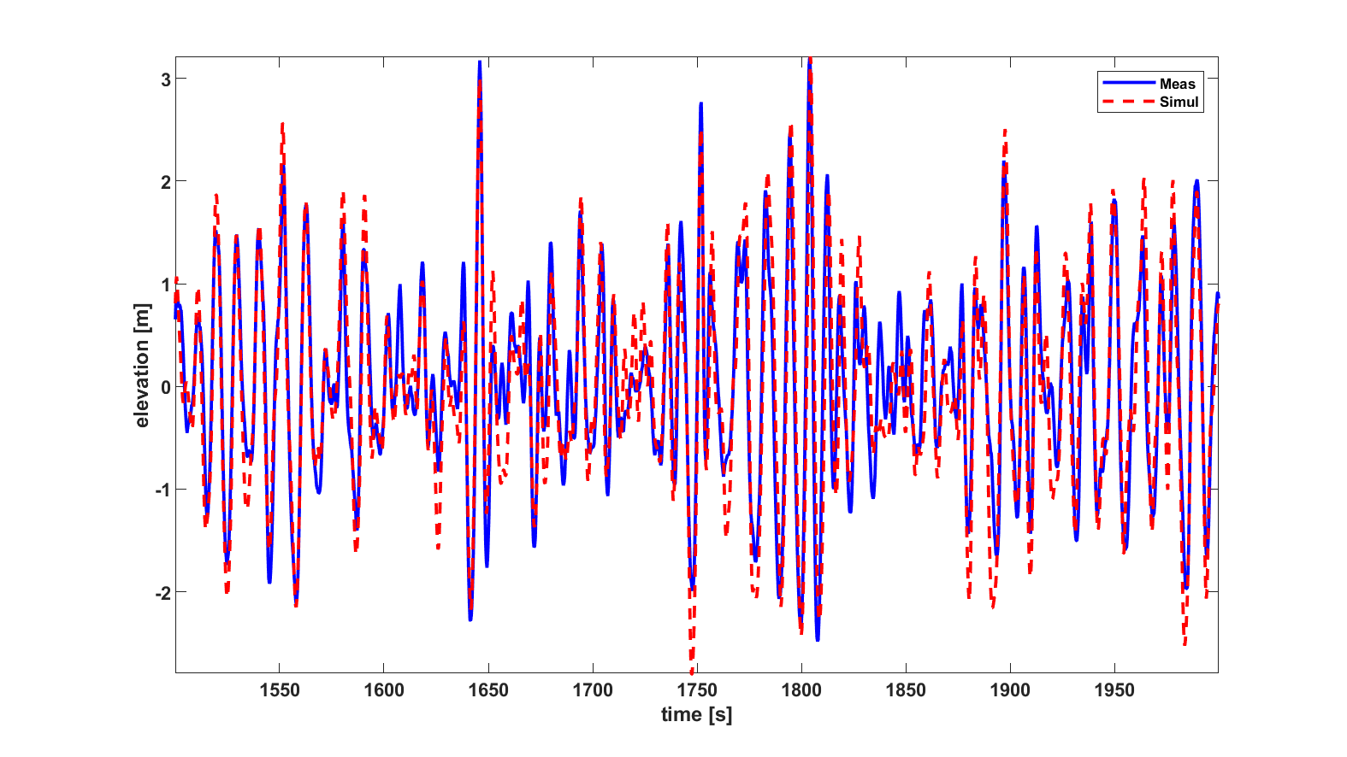

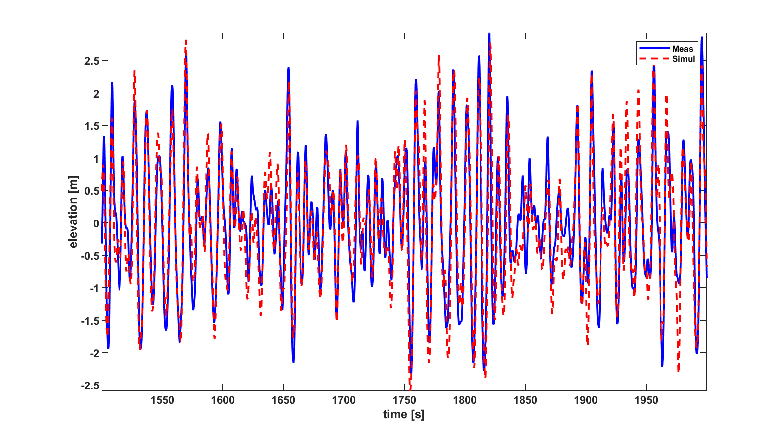Irregular wave runup on a shore. Top plot show wave elevation at time t=1726 s, Lower plots from top to bottom are wave signals comparison between measurement (blue) and simulation (red) for buoys at (x,y)=(1100,0), (1646,0) and (1740,0) [m].

Dynamic Model : HS2

Dispersion Model : Exact

Signal type : User-defined (signal)

Amplitude (A) : 3.33 [m]

Peak period (Tp) : 10.205 [s]

Mean period (Tm01) : 100.005[s]

Direction (degree) : 9.291 [deg]

Depth at influxing (h) : 76.7049 [m]

Derived info:

Peak frequency (nu) : 0.616 [rad/s]

Mean frequency : 0.676 [rad/s]

Peak wave-number (kp) : 0.039

Peak wave-length : 161.763[m]

Peak phase speed : 15.851 [m/s]

Peak group speed : 8.17 [m/s]

Steepness (kp*(Hs./2)) : 0.065

Relative wave-length(lambda/h): 2.1089(Intermediate depth)

(kp*h) : 2.979

Y. N. Liu, B. Molin, O. Kimmoun, F. Remy, M.-C. Rouault. Experimental and numerical study of the effect of variable bathymetry on the slow-drift wave response of floating bodies. 2011. *Applied Ocean Research* 33, 199-207

# References

**Publication or report using HAWASSI should refer to:**

* R. Kurnia & E. van Groesen, High Order Hamiltonian Water Wave Models with Wave-Breaking Mechanism, *Coastal Engineering* **93** (2014) 55–70
* R. Kurnia & E. van Groesen, Localization for spatial-spectral implementations of 1D Analytic Boussinesq equations, *Wave Motion,* **72** (2017) 113-132
* E. van Groesen & Andonowati, Hamiltonian Boussinesq formulation of Wave-Ship interactions, Part 1: Evolution equations, *Applied Mathematical Modelling.* **42** (2017) 133-144

## References to basic papers and applications

1. R. Kurnia, E.van Groesen, Hamiltonian Boussinesq Simulation of Wave-Body Interaction Above Sloping Bottom, *IJOPE,* ***32*** *(2022) 244-252*
2. R. Kurnia, P. Turnip, and E. van Groesen.Spectral AB Simulations for Coastal and Ocean Engineering Applications. In *Murali K., Sriram V., Samad A., Saha N. (eds) Proceedings of the Fourth International Conference in Ocean Engineering (ICOE2018). Lecture Notes in Civil Engineering, vol 23*. Springer, Singapore 2019.
3. R. Kurnia, M.R. Badriana & E. van Groesen, Hamiltonian Boussinesq simulation for waves entering a harbour with access channel, *J. Waterway, Port, Coastal, Ocean Eng.* (2018) **144(2)**:04017047 1-14
4. E. van Groesen, P. Turnip & R. Kurnia, High waves in Draupner seas, Part 1: Numerical simulations and characterization of the seas, *J. Ocean Engineering and Marine Energy,* **3** (2017) 233-245
5. R. Kurnia & E. van Groesen, Localization for spatial-spectral implementations of 1D Analytic Boussinesq equations, *Wave Motion,* **72** (2017) 113-132
6. E. van Groesen & Andonowati, Hamiltonian Boussinesq formulation of Wave-Ship interactions, Part 1: Evolution equations, *Applied Mathematical Modelling.* **42** (2017) 133-144
7. R. Kurnia, Simulations of extreme wave runup on a vertical wall, *OMAE 2016-54365,* 8 pages
8. R. Kurnia, T. van den Munckhof, C.P. Poot, P. Naaijen, R.H.M. Huijsmans & E. van Groesen, Simulations for design and reconstruction of breaking waves in a wavetank, *OMAE 2015* Vol2,41633, 7 pages
9. R. Kurnia & E. van Groesen, Spatial-spectral Hamiltonian Boussinesq wave simulations, Advances in Computational and Experimental Marine Hydrodynamics, VOL. 2 Conference Proceedings, 2015, pp. 19-24,*ISBN: 978-93-80689-22-7*R.
10. R. Kurnia & E. van Groesen, Design of Wave Breaking Experiments and A-Posteriori Simulations, Memorandum 2042, (January 2015), <http://www.math.utwente.nl/publications> ISSN 1874−4850
11. R. Kurnia & E. van Groesen, Localization in Spatial-Spectral Methods for Water Wave Applications, *Proceedings ICOSAHOM* 2014.
12. W. Kristina. O. Bokhove & E. van Groesen, Effective coastal boundary conditions for tsunami wave run-up over sloping bathymetry, *Nonlin. Processes GeoPhys*, **21**(2014) 987-1005
13. Lie S Liam, D. Adyia & E. van Groesen, Embedded wave generation for dispersive surface wave models, *Ocean Engineering* **80** (2014) 73-83
14. R. Kurnia & E. van Groesen, High Order Hamiltonian Water Wave Models with Wave-Breaking Mechanism, *Coastal Engineering* **93** (2014) 55–70
15. Lie She Liam, Mathematical modelling of generation and forward propagation of dispersive waves PhD-Thesis UTwente, 15 May 2013
16. A.L. Latifah & E. van Groesen, Coherence and Predictability of Extreme Events in Irregular Waves,*Nonlin. Processes Geophys*, **19** (2012)199-213
17. E. van Groesen *&* I. van der Kroon, Fully dispersive dynamic models for surface water waves above varying bottom, Part 2: Hybrid spatial-spectral implementations, *Wave Motion* **49**(2012) 198-211
18. E. van Groesen *&* Andonowati, Fully dispersive dynamic models for surface water waves above varying bottom, Part 1: Model equations, *Wave Motion* **48**(2011) 657-666
19. E. van Groesen *&* Andonowati, Time-accurate AB-simulations of irregular coastal waves above bathymetry, Proceedings of the *Sixth International Conference on Asian and Pacific Coasts* (APAC 2011) December 14 – 16, 2011, Hong Kong, China, World Scientific ISBN: 978-981-4366-47-2, pp.1854-1864
20. E. van Groesen, T. Bunnik *&* Andonowati, Surface wave modelling and simulation for wave tanks and coastal areas, *International Conference on Developments in Marine CFD, 18 - 19 November 2011, Chennai, India,* RINA, ISBN: 978-1-905040-92-6, p. 59-63
21. L. She Liam & E. van Groesen, Variational derivation of KP-type equations, *Physics Letters A*, **374**(2010) 411-415
22. E. van Groesen*,* Andonowati, L. She Liam & I. Lakhturov, Accurate modelling of uni-directional surface waves, *Journal of Computational and Applied Mathematics* 234 (2010) 1747-1756
23. E. van Groesen*,* L. She Liam, I. Lakhturov & Andonowati, Deep water Periodic waves as Hamiltonian Relative Equilibria, *Proceedings of Waves 2007*, N. Biggs e.a. (eds), Reading UK, 23-27 July 2007, pp. 482-484;
24. E. van Groesen & Andonowati, Variational derivation of KdV-type of models for surface water waves, *Physics Letters A* **366** (2007)195-201

## Other references

Beji & Battjes

* S. Beji &J. Battjes, Numerical simulation of nonlinear wave propagation over a bar, *Coastal Engineering* **23** (1994) 1 – 16.
* S. Beji & J. Battjes, Experimental investigation of wave propagation over a bar, *Coastal Engineering* **19** (1993) 151 – 162.

BBM

* T.B. Benjamin, J.L. Bona & J.J. Mahony, On model equations for long waves in nonlinear dispersive systems, *Phil. Trans. Roy. Soc. London* **A272** (1972)47

Broer

* L.J.F. Broer, Approximate equationsn for long water waves, *Appl. Sc. Res.*, **31**(1975)377-395

KdV

* D.J. Korteweg & G. de Vries, On the change of form of long waves advancing in a rectangular canal and a new type of long stationary waves, *Phil. Mag.* **39**(1895)422

Liu

* Y. N. Liu, B. Molin, O. Kimmoun, F. Remy, M.-C. Rouault. Experimental and numerical study of the effect of variable bathymetry on the slow-drift wave response of floating bodies. 2011. *Applied Ocean Research* 33, 199-207

Ting& Kirby

* F. C. Ting & J. T. Kirby, Observation of undertow and turbulence in a laboratory surf zone, Coastal Engineering **24** (1994) 51 – 80.

Wei e.a.

* G. Wei, J. T. Kirby, S. T. Grilli & R. Subramanya, A fully nonlinear Boussinesq model for surface waves. Part 1. Highly nonlinear unsteady waves, *Journal of Fluid Mechanics* **294** (1995) 71–92.

Zakharov

* V.E. Zakharov, Stability of periodic waves of finite amplitude on the surface of a deep fluid, *J. of Mechanics and Technical Physics* **2**(1968)190-194